DONEGAL LOCAL AUTHORITIES



Recommendations for
Site Development Works for
Housing Areas in Donegal

Date: 16th November 2007

FOREWORD

This document, which is based on a Department of the Environment and Local Government publication, is intended for the guidance of Donegal Local Authorities, Public Authorities, Private Developers and Consultants, in the construction of site development works for housing areas in County Donegal.

The document sets out recommended standards and technical specifications for the various services, which should generally be acceptable to local authorities, in their administrative areas.

This publication does not contain all of the possible solutions to site development design problems and designers should be encouraged to propose imaginative alternatives, subject to approval as defined in the document.

This document does not deal with issues of estate layout. Nevertheless, it is recognised that layouts which seek to ensure very low traffic speeds and greater priority for pedestrians and cyclists within housing areas should be encouraged. In particular circumstances, this consideration might well justify the adoption of standards other than those contained in this document.

This document shall be periodically reviewed.

i

Contents
Clause Page

FOREWORD i

SECTION 1: GENERAL

1.1 Definitions 2
1.2 Scope 3
1.3 Technical Specifications 3
1.4 Materials 3
1.5 Consultation with Local Authority 4
1.6 Information Required 5
1.7 Other Services 6
1.8 Access 6
1.9 Completion 6
1.10 Legal 6

SECTION 2: ROADS AND FOOTWAYS

2.1 Layout Design 8
2.2 Roadway Width 8
2.3 Junctions 8
2.4 Junction Sightlines 8
2.5 Junction Radii 9
2.6 Cul-de-sacs 10
2.7 Road Gradients 11
2.8 Road Crossfall 12
2.9 Horizontal Alignment 12
2.10 Driveways 12
2.11 Screen Walls 12
2.12 Services 12
2.13 Clearance 13
2.14 Specification 13
2.15 Roadway Construction 13
2.16 Subgrade Strength 14
2.17 Depth of Sub-base and Capping Layer 14
2.18 Capping Layer Material 15
2.19 Sub-base Material 15
2.20 Roadbase Material 15
2.21 Concrete Roadways 17
2.22 Block Paving Roadways 21
2.23 Flexible Roadways 21
2.24 Safety Barriers 23
2.25 Footways 23
2.26 Kerbs 23

Clause Page

2.27 Cement 24
2.28 Concrete Aggregates 24
2.29 Traffic Calming 24
2.30 Wheel Cleaning Facilities 24
2.31 Cycle Tracks 24
2.32 Children at Play Signs 24

SECTION 3: SEWERS AND DRAINS

3.1 Compliance 26
3.2 Separate Systems 26
3.3 Pipe Types 26
3.4 Pipe Sizes and Gradients, Surface Water 26
3.5 Pipe Sizes and Gradients, Foul Water 28
3.6 Bedding and Cover, Rigid Pipes 28
3.7 Bedding and Cover, Flexible Pipes 30
3.8 Trench Width 31
3.9 Trench Compaction 31
3.10 Accessibility 31
3.11 Access to Sewers 31
3.12 Drain to Sewer Connections 32
3.13 Joints 32
3.14 Manhole Construction 32
3.15 Manhole Dimensions 33
3.16 Channels and Benching 34
3.17 Manhole Covers and Frames 34
3.18 Manhole Steps and Ladders 35
3.19 Gullies 35 3.20 Testing of Sewers and Drains 36
3.21 Manhole Infiltration 36
3.22 Cleaning of Sewers and Drains 36
3.23 Sewer Diversions 37
3.24 Grease Removal 37
3.25 Pumping Stations 38
3.26 Rising Mains 38
3.27 Wastewater Treatment Plant 38

SECTION 4: WATER SUPPLY
4.1 Supply 40
4.2 Watermain Pipes 40
4.3 Service Pipes & Fittings 41
4.4 Watermain Pipe Size and Layout 41

Clause Page

4.5 Location of watermains 42
4.6 Pipe Cover 42
4.7 Pipe Laying 42
4.8 Pipe Jointing 42
4.9 Marker Tape 42
4.10 Pipe Anchorage 43
4.11 Sluice Valves 43
4.12 Hydrants 44
4.13 Air Valves 45
4.14 Stopcocks 45
4.15 Valve Chambers 45
4.16 Surface Boxes 45
4.17 Indicator Plates and Marker Posts 49
4.18 Testing and Sterilisation 49
4.19 Inspection 49
4.20 Authorised Personnel 49
4.21 Scour Valves 50
4.22 Meters 50
4.23 Pressure Reducing Valve 50
4.24 High Level Developments & Buildings 51
4.25 Notification 52
4.26 Liability for Damage to Existing Mains 52
4.27 Transportation & Storage 52
4.28 Wayleaves & Easements 52
4.29 Water Storage 52
4.30 EEC Directive on Pipes & Fittings 53
4.31 Contacts 53

SECTION 5: PUBLIC LIGHTING

5.0 General / Introduction 55
5.1 Lighting Standards 55
5.1.1 Lighting Design 55
5.1.2 White Light Exceptions 55
5.2 Lighting Layout 55
5.2.1 Minimum Clearances Required 55
5.2.2 Column / Mounting Height 56
5.2.3 Lighting Arrangements 56
5.2.4 Traffic Calming Measures 63
5.2.5 Conflict Areas 63
5.3 Lighting Equipment 64
5.3.1 Electrical 64
5.3.2 Lanterns 64
5.3.3 Columns 64

Clause Page

5.3.4 Ducting 64
5.3.5 Column Foundation 65
5.4 Certification 66
Schedule: DL – LP 67
Schedule: DL – LC 71

Appendix A – Specification for Water Pumping Stations

1 General Design Criteria 74
2 Required Drawings 74
3 Pumping Station 75
4 Drinking Water Sump Storage 75
5 Control House 75
6 Pumps 77
7 Commissioning 78
Appendix B – Specification for Wastewater Pumping Stations

1 General Design Criteria 80
2 Required Drawings 80
3 Pumping Station 81
4 Emergency Overflow Chamber 82
5 Control House 82
6 Pumps 83
7 Commissioning 85
Appendix C – Specification for Wastewater Treatment Plants

1 General Design Criteria 87
2 Required Drawings 87
3 Treatment Plant 87
4 Emergency Overflow Chamber 88
5 Control House 88
6 Quality of Final Effluent 88
7 Commissioning 88

Clause Page

FIGURES

SECTION 2:

2.1 Clear Sight-triangle 9
2.2 Residential Turning Bays 10
2.2.1 Handrails 11
2.2.2 Service Laying 12
2.3 Terminology for Roadway Construction 13
2.4 Transverse Contraction Joint 19
2.5 Transverse Expansion Joint 19
2.6 Longitudinal Joint 20
2.7 Formed Contraction Joint 20
2.8 Flexible Roadway Surfacing 22
2.9 Pedestrian Drop Kerb 24

SECTION 3:

3.1 Bedding and Surround for Rigid Drainage Pipes 29
3.2 Bedding and Surround for Flexible Drainage Pipes 30

SECTION 4:

4.1 Airvalve 46
4.2 Fire Hydrant 46
4.3 Sluice Valve 47
4.4 Stopcock 47
4.5 Marker Post 48
SECTION 5:

5.2.3.1 T-Junctions on Straight Roads 57
5.2.3.2 T-Junctions on Bends 58
5.2.3.3 Staggered Junctions 59
5.2.3.4 Crossroads 60
5.2.3.5 Y-Junctions 61
5.2.3.6 Fork-Junctions 62
5.3.4 Public Lighting Ducting Details 65
5.3.5 Public Lighting Foundation Details 66
Light Pollution 67
Public Lighting Zones 72

- SECTION 1
- GENERAL

1

Section 1: General

1.1 Definitions For the purposes of this document, the following definitions apply:

- Local Authority: The Local Authority that will assume responsibility for the development works on their completion.

- Developer: The person, company or public body that undertakes the development works and from whom the Local Authority would take the development in charge.

- Approval: "Approval" and "Approved" mean approval in writing by the Local Authority, of proposals submitted by the developer. This meaning does not extend to a planning application for "approval", unless it is specifically stated as such.

- Road: A way for vehicles and other types of traffic.

- Roadway: That portion of a road, which is provided primarily for the use of vehicles.

- Footpath: A road over which there is a public right of way for pedestrians only, not being a footway.

- Footway: That portion of any road associated with a roadway, which is provided primarily for use by pedestrians.

- Drain: Any underground pipework or conduit used for the conveyance of foul water or surface water, which is not intended to be taken over and maintained by the Local Authority.

- Sewer: Any underground pipework or conduit used for the conveyance of foul water or surface water, which is intended to be taken over and maintained by the Local Authority.

- Foul Water: Waste water, or trade effluent, or water containing excreted matter, whether human or animal.

- Surface Water: The run-off of rainwater from roofs and paved ground surfaces.

- Watermain: A pipe for the general distribution of water in a water supply system, not being a service pipe.

- Service Pipe: A pipe for the conveyance of water from a watermain to an individual premises.

2

1.2 Scope This document sets out recommended standards and technical
specifications for the design and construction of roads and services associated with site development works for housing areas. It does not deal with workmanship criteria.

The design of all services must allow for future development of the Site’s catchment area as could reasonably be expected under Donegal Co. Councils County Development Plan.

The roads and services within the scope of this document are:

1. All roads within housing areas, with the exception of those intended:

- as the principal means of access to more than 200 houses.
- for use on bus routes.
- to provide a through route for vehicular traffic.

2. Sewers and drains comprising pipes up to 300mm diameter.

3. Water mains up to 225mm diameter and water service pipes.

- Public Lighting within the housing area.

1.3 Technical Specifications Within this document, technical specifications are either provided directly, or indirectly by reference to:

- An Irish Standard Specification, identified by IS followed by a number and the year of publication.

- A British Standard Specification, identified by BS followed by a number and the year of publication.

- A harmonized European Standard Specification, identified by IS EN followed by a number and the year of publication.

- Other published specifications, identified by their titles.

References to Irish, British and harmonized European Standard Specifications and any other published specifications, are to the latest edition current at the time of publication of this document. However, if this edition of the technical specification is subsequently revised or updated by the issuing body, the new version should be deemed to apply, unless approval is obtained to the contrary.

1.4 Materials All works should be carried out with proper materials. Proper materials means materials which are fit for the use for which they are intended and for the conditions in which they are to be used, and includes materials which:

3
- Bear a CE Marking in accordance with the provisions of the Construction Products Directive; or

- Comply with an appropriate harmonized standard, European technical approval or national technical specification as defined in article 4(2) of the Construction Products Directive; or

- Comply with an appropriate Irish Standard or Irish Agrément Board Certificate or with an alternative national technical specification of any State, which is a contracting party to the Agreement on the European Economic Area, which provides in use an equivalent level of safety and suitability.

1.5 Consultation with Local Authority requirements vary on the nature and degree of
Local Authority consultation that is necessary, in relation to proposed housing developments in their individual administrative areas.

Prior to finalising the design of a proposal, the Developer is advised to ascertain the particular consultation process that obtains in the specific area, as well as the name(s) of the appropriate officer(s) for consultation purposes, on matters of Planning, Roads, Drainage, Watermains and Public Lighting. The Developer is furthermore advised to consult, at the earliest possible opportunity, with the appropriate officer(s) on matters such as:

- Planning: Site suitability, layout design, housing density, open spaces, landscaping, etc.

- Roads: Road widths, road reservations, road widening lines, culs-de-sac, junction sightlines and radii, gradients, alignments, roadway type, traffic calming, proposed construction traffic; inspection, testing and approval requirements, etc.

- Drainage: The type of drainage system to be used, areas external to the development area whose drainage is required to be included (together with estimated discharge data), outfall points or connections to existing sewers, types of manhole and gully covers; inspection, testing and approval requirements, etc.

Where the drainage layout is such as to require one or more connections to a public sewer, the Developer should ascertain whether or not the connections would be carried out by the Local Authority. Where these connections would be carried out by the Developer, the Local Authority requirements should be determined.

- Watermains: Availability of water supply, fire fighting requirements, type and layout of watermain, connection points, types of surface boxes, locations of indicator plates and marker posts; inspection, testing and approval requirements, etc.

- Public Lighting: Lighting pollution policy, lighting design, light source, installation by ESB or private contractor, types of lighting column, lantern, lamp, ducting, cables, controls; inspection, testing and approval requirements, etc.

4
1.6 Information Required The following information should be submitted by the Developer to the Local Authority. (This information may be included in the Developer's application for Planning Permission, or Approval, or may take the form of such documentation, together with supplementary data, all subject to approval.

- A layout plan of the proposed development, showing the extent of the development site, site contours levels at 0.5m intervals, the location of boundaries and structures within the site and the location and levels of existing utilities, including those within the site as well as those external to the site, that would be affected by the development.

- A plan showing the arrangement of the houses, with proposed ground floor levels, the layout of roads, footpaths, footways, sewers and drains, including sewer and drain sizes and positions of manholes and gullies.

- A plan showing the layout of proposed watermains, including pipe sizes and positions of hydrants and valves.

- Longitudinal sections and cross-sections of roads, indicating the proposed road construction, levels and gradients.

- Longitudinal sections of proposed sewers and drains, showing levels, gradients, sizes, types and classes of pipe, types of joint and types of bedding, haunch and surround.

- Longitudinal sections of proposed watermains, showing sizes, types and classes of pipe and positions of valves and hydrants.

- A layout plan with sections of the proposed public lighting system, showing the location of lighting columns, auxiliary micro pillars and ducting and specifying the types of equipment to be provided. Details of the internal electrical arrangement for lighting columns and auxiliary micro pillars, as well as details of the overall earthing arrangements should also be included.

- Drainage design calculations, demonstrating the capacity of the proposed pipe networks to discharge the design flows and run-off from the development.

- Proposals for the treatment of existing surface and underground water-courses, boundaries and structures, within the development.

- Proposals for the preservation of existing trees and other features.

- General arrangement drawings for any water pumping station and sump chamber (if required) clearly identifying, access, valves, scour main and pipework in vicinity of the station. Pump details including performance curve and power rating, manufacturers data sheet for proposed flow meter, manufacturers standard annual maintenance contract, warranty documents for equipment and a list of the manufacturers recommended spare parts for 20 years of operation, including the current cost for each item, should also be submitted.
5

- General arrangement drawings for any treatment plant including access, each stage process, mechanical and electrical arrangements and emergency overflow chamber (when required). Drawings should clearly show the invert levels of all pipes connecting to chambers, overflows, cut-in and cut-out levels etc. Manufacturers standard annual maintenance contract, pump details including performance curve and power rating, manufacturers data sheet for proposed flow meter, warranty documents for equipment and a list of the manufacturers recommended spare parts for 20 years of operation, including the current cost for each item, should also be submitted.

Site layout plans should be to a scale of not less than 1:500. Sections and elevations should be to a scale of not less than 1:100. All levels shown should be related to Ordnance Datum.

1.7 Other Services With regard to services other than those being provided directly by the Developer e.g. electricity, telecommunications, gas, piped television etc., the Developer should comply with the requirements of statutory undertakers, or public utility companies responsible for such services. In relation to services on offer from private companies, the Developer should ascertain the Local Authority requirements in each specific instance.
All necessary ducting for services under roads should be installed, at the approved locations and depths, prior to completion of the road surfacing.

1.8 Access Access to the site should be made available to Local Authority staff, for such monitoring or inspection of work as may be required, during construction.

1.9 Completion On completion of the project, the Developer should submit to the Local Authority, such as constructed records as the Local Authority may require.
This will include a site-specific safety statement with associated risk assessments covering all operation and maintenance activities, which should form a part of the scheme’s safety file. The safety file is a record of information for the end user, which focuses on health and safety and must be made available to Donegal County Council before handover of the estate. This may entail the provision of some, or all of the drawings detailed in 1.6 above, but might also require the provision of closed circuit television sewer condition surveys, by approved contractors, with results presented on diskette, tape, compact disc, or other approved device.

1.10 Legal Compliance with these recommendations does not confer immunity on the Developer from any legal requirements and does not remove the obligation on the Developer to comply with the requirements of the Planning Acts, relevant sections of the Building Regulations, the Safety Health and Welfare at Work Acts.

6

- SECTION 2

ROADS AND FOOTWAYS

7

Section 2: Roads and Footways

Design
2.1 Layout Design Layouts should be designed so as to deter through traffic. Road alignments should be such as to limit vehicle speeds and facilitate pedestrian movement. Adequate access for wheelchairs and prams should be provided.

2.2 Roadway Width The width of roadway may vary to take account of the character of development and its area, the design concept for the scheme and the function of the road in the roads hierarchy

2.3 Junctions All junctions should be designed with a proper regard for the safety of all
road users.

Road markings and STOP signs must be provided at all major junctions within the development in accordance with Department of Environment and Local Governments “Traffic Signs Manual.” The STOP line should consist of a single continuous white line 200mm in width that should not be closer than 600mm to the edge of the major road. The STOP transverse marking should always be accompanied by a central continuous longitudinal line extending back from the junction for a minimum distance of 20m from the STOP line.

All STOP lines must be accompanied by a stop sign positioned between 1.5m and 6m in advance of the STOP line on the left hand side of road. This should be provided at back of footpath. The height of sign should be positioned to give clear headroom of 2.2m for pedestrians. Fixing clips must have anti rotational grooving and posts must be drilled to allow for the use of anti rotational pins

Irish only language signs to be provided in Gaeltacht areas.

2.4 Junction Sightlines Vision lines at junctions should be in accordance with table 2.1. Permanent visibility splays shall be provided to enable emerging drivers

using the direct access to have adequate visibility in each direction to see oncoming traffic in sufficient time to make their manoeuvre safely without influencing the major road traffic speed. Deviation from the requirements in Table 2.1 may be considered upon certification by the Applicants Designer that the junction has been designed in accordance with NRA’s Design manual for Roads and Bridges. Figure 2.1 details the method by which the site envelope should be calculated.

8

Type of Road | Regional Road | Local Road
Cul de Sac up to 6 dwellings | 90m-120m x 2.4m  Y x X | 70m- 90m x 2.4  Y x X
Direct Access/Junction* point with design year**AADT<500 | 120m-160m x 4.5m  Y x X | 90m-120m x 4.5  Y x X
Direct Access/Junction* Point with design year**AADT>500 | 160m-215m x 9.0m  Y x X | 120m-160m x 9.0m  Y x X

* AADT - vehicular movements exiting & entering new estate access
** Design year is 20 years after date of planning application

Table 2.1

Y distance
X Distance
Y distance
Envelope of visibility
Access

Figure 2.1

2.5 Junction Radii Junction radii should be designed to permit all road users to negotiate the junction safely. The radii may vary to take account of the character of development and its area, the design concept for the scheme and the function of the roads in the roads hierarchy

- Kerb radii at junctions of roads to which these recommendations refer, should be a minimum of 6m.

- Kerb radii at a junction between an estate road and a road not covered by these recommendations, should be a minimum of 10.5m.

At particular junctions, in order to minimise crossing distance for pedestrians, lower radii than those stipulated in 1. and 2. above may be more appropriate, subject to approval of the Local Authority.

9

2.6 Cul-de-sacs Turning bays should be provided at appropriate locations and designed with due regard to safety. The dimensions required for turning bays in residential cul-de-sacs depend both on the maximum size of vehicle to be accommodated and on the frequency with which the turning bay would be used by that vehicle.

Figure 2.2 illustrates suggested turning bays. The types (i), (ii) and (iii) shown on the figure, should enable most large refuse vehicles, or fire engines, to turn by means of a three point turn. Other types of turning bay may well be acceptable subject to the certification of the Applicants Designer and approval of Local Authority. For type (iv) turning bay the radius should be 10m in all circumstances.

10

2.7 Road Gradients Longitudinal gradients should normally lie between 0.5% and 5%, but a higher minimum gradient of up to 1% may be required, depending on the type of surface and the method of application.

The table below is indicative of maximum gradients permissible at junctions.

Access Point | Side Road at Junction
Three Single dwelling Accesses or less | 7m @ 4% Gradient
Multiple Access with less than 500AADT | 15m @ 4% Gradient
Multiple Access with greater than 500AADT | 15m @ 2% Gradient

Table 2.1.1

Where gradients exceed 5%, type B or type C surfacing materials must be used as per clause 2.23 for entire length of excessive gradient and extending 10m minimum on either side. In such circumstances handrails will be required at back of footpath in accordance with figure 2.2.1. Local Authority approved saltboxes should also be provided in locations shown on design drawing or as directed by Donegal Co. Council

Handrail at back of Footpath
700
840 – 900
45
45
30
30
Diameter 45/50
Diameter 25-32

Handrail Detail where wall present

Figure 2.2.1

11

2.8 Road Crossfall Camber/crossfall of 2.5% should be provided for a normal machine
laid surface. This may be increased to 3% where appropriate.

2.9 Horizontal Roads should normally be designed and located to intersect at angles of between 70 and 110 degrees and preferably at 90 degrees. Where one road crosses or meets another at an angle outside this range, suitable curves should be introduced in the alignment of the minor road, subject to approval, in order to improve the angle of intersection.
Alignment

2.10 Driveways Driveways should have a minimum width of 3m. Normally a gradient of 0.5% - 5% should be provided. Gradients in excess of 5% in exceptional circumstances may be considered subject to submission of appropriate justification and approval of Local Authority. A kerb upstand of 25mm should be provided at entrances.

2.11 Screen Walls Screen walls should be constructed in accordance with the requirements of IS 325

2.12 Services Services should be laid in accordance with figure 2.2.2

Minimum width of 10m is required for any way-leaves for all services traversing private property. This width may be reduced in certain circumstances only after consultation with Donegal County Council.
- If any service is passing through private property, proof of approval
for wayleave / easement rights should be obtained in advance of notification to the Local Sanitary Authority and submitted with the planning application and water connection application.

Figure 2.2.2

12
2.13 Clearance The normal minimum lateral clearance of fixed objects from the roadway
edge should be one metre. This applies to items such as public lighting columns, posts, trees and piers at entrances to developments. Particular circumstances may require that this clearance be reduced. In no circumstance should this clearance be less than 450mm.

Construction

2.14 Specification Road works should comply with the requirements of "Specification for
Road Works" published by the National Roads Authority.

2.15 Roadway The roadway construction comprises the pavement layers and the pavement
Construction foundation. The pavement may be constructed using flexible materials,
block paving, or in situ concrete. The pavement foundation comprises the sub-base and capping layer, laid over the natural subgrade soil.

The various construction options and the terminology for roadway construction are illustrated in Figure 2.3. In situ concrete, or flexible roadway, are the general forms of construction. Other forms, such as concrete paving blocks, or clay or calcium silicate pavers may also be appropriate, subject to approval.

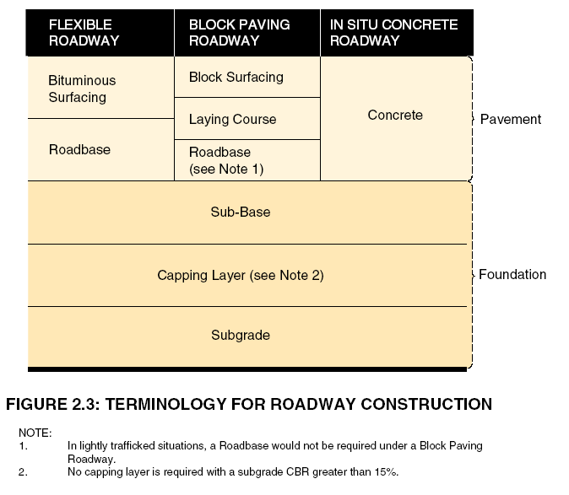

13
2.16 Subgrade Strength Subgrade strength should be established by means of the California Bearing
Ratio (CBR) Test, in accordance with BS 1377: Part 4: Section 7. Samples should be taken at the rate of one per 100m of road and where significant variations in soil type are anticipated. Extra samples may be required by the Local Authority where the difference in strength between two adjacent samples indicates a significant variation in soil type. In preparing the test specimen, the method of compaction should be the Static Compaction Method 2, as specified in paragraph 7.2.3.3 of BS 1377: Part 4.

The moisture content and density conditions used in the test should reproduce, as closely as possible, the conditions likely to apply under the road after construction. To estimate the appropriate density condition, a preliminary test may be carried out using the vibrating hammer method of compaction given in BS 1377: Part 4: Section 3, but with the soil at the expected average moisture content after construction. The CBR specimen should then be compacted to a density corresponding with 95% of the value obtained in the preliminary test.

In establishing subgrade strength, due account should be taken of the likely impact of the construction phase on the characteristics of the subgrade material. This may be critical, particularly on a site with a relatively high water table or poor drainage parameters. In such cases, the in-service long term strength of the subgrade may be considerably less than that of the same soil in an undisturbed condition.

For subgrades with a CBR of less than 2%, a geotextile separator should be used and specialist advice should be sought regarding minimum thicknesses.

2.17 Depth of Sub-base The depth of the sub-base and capping layers will vary with the subgrade
& Capping Layer strength, as indicated by the CBR test results.

The thickness of the sub-base layer should be 150mm for all forms of roadway construction.

The thickness of the capping layer will vary with the CBR value, as indicated in Table 2.2. As can be seen from the table, if the CBR value of the subgrade exceeds 15%, no capping layer is required.

TABLE 2.2 Capping Layer - Minimum Construction Thicknesses
____________________________________________________________
Lowest Subgrade Minimum capping layer thickness
CBR (mm)
(%)
____________________________________________________________
* Less than 2 (See footnote)
2-5 300
5-15 150
more than 15 no capping layer required
____________________________________________________________

* For subgrades with a CBR of less than 2%, a geotextile separator should be used and specialist advice sought regarding minimum thicknesses.
Where local weak areas of subgrade strength exist, increased construction thicknesses, as approved, should be provided.
14
Where the Contractor proposes to use the sub-base for construction plant and traffic, it may be necessary to strengthen the sub-base (and capping layer, if any), in order to accommodate the method of construction and the type of plant and traffic proposed. It might well be, that the loading conditions during the construction phase could be more onerous than those experienced when the pavement is in full service. The thickness of sub-base (or capping layer and sub-base) required in such cases, would be dependent on the CBR of the subgrade and the construction traffic, as measured in Standard Axles. The Contractor's proposals in this regard are subject to approval. Any permanent thickening required should be across the entire width of the foundation, unless otherwise approved. Temporary thickening should not impede drainage of the sub-base or subgrade.

Damage caused by construction traffic should be remedied, as approved, before construction of the pavement layers.

2.18 Capping Layer Capping layer material should comprise either crushed rock, natural gravel,
Material crushed gravel, or crushed concrete. The material should have a maximum size of 100mm and the maximum allowable passing the 75 micron sieve should be 10%. The material should be well graded throughout all sizes.

Selected demolition materials which meet the above requirements may also be used, subject to approval.

2.19 Sub-base Material Sub-base material should comprise Type B granular material, in accordance
with Clause 804 of the Specification for Roadworks. The material should lie within the grading limits set out in Table 2.3.

TABLE 2.3 Sub-base Material - Range of Grading
__________________________________________________________
Sieve size Percentage by
IS 24 mass passing
____________________________________________________________
75 mm 100
37.5mm 85-100
10 mm 40-70
5 mm 25-45
600 µm 8-22
75 µm 0-10
____________________________________________________________

Particle size distribution should be determined by the washing and sieving method of BS 812: Part 103. All material used should be frost resistant

Material passing the 425µm sieve, when tested in accordance with BS 1377, should be non-plastic.

The material should have a ten percent fines value of 100kN, or more, when tested in accordance with BS 812.

The sub-base should be laid and compacted to the requirements of Clause 802 of the Specification for Roadworks, without drying out, or segregation.
Other materials may be used, subject to approval.

2.20 Roadbase Material Roadway roadbase material should normally comprise lean mix concrete,
wet mix macadam, dry bound macadam, or dense bitumen macadam.
15
- Lean mix concrete: Aggregates for lean mix concrete may consist of either coarse and fine aggregate batched separately, or an all-in aggregate, having a maximum nominal size not exceeding 40mm nor less than 20mm and should lie within the grading limits set out in Table 2.4

TABLE 2.4 Lean mix concrete - Range of Grading
____________________________________________________________
Percentage by mass passing
____________________________________________________________
Sieve size Nominal maximum size
IS 24 40mm 20mm
____________________________________________________________
75 mm 100 100
37.5 mm 95-100 100
20 mm 45-80 80-100
5 mm 30-40 35-45
600 µm 8-30 10-35
150 µm 0-6 0-6
______________________________________________________________

Particle size distribution should be determined by the washing and sieving method of BS 812: Part 103. The ratio, by mass of cement to aggregate, should be such as to produce 28 day cube strengths of not less than 10N/mm2 and not more than 20N/mm2.

- Wet Mix Macadam: Wet mix macadam should consist of crushed rock, lying within the grading limits set out in Table 2.5.

TABLE 2.5 Wet Mix Macadam - Range of Grading
________________________________________________________________
Sieve size Percentage by mass passing
IS24
________________________________________________________________
50 mm 100
37.5 mm 95-100
20 mm 60-80
10 mm 40-60
5 mm 25-40
2.36 mm 15-30
600 µm 8-22
75 µm 0-8
________________________________________________________________

Particle size distribution should be determined by the washing and sieving method of BS 812: Part 103. The moisture content of the wet mix macadam should be the optimum +0.5%, as determined by the vibrating hammer method test, in accordance with BS 1377.
- Dry-bound Macadam: Dry-bound macadam should consist of coarse and fine aggregate. The coarse aggregate should consist of crushed rock complying with the 50mm, or the 40mm nominal sizes of BS 63 and the fine aggregate should all pass the 5mm IS sieve size. The coarse aggregate should be compacted in 100mm layers and fine aggregate, as required, vibrated into the voids of the coarse aggregate.
16
- Dense Bitumen Macadam: Dense bitumen macadam should be 40mm nominal size dense roadbase, in accordance with BS 4987: Part 1.
Roadbase materials should be compacted in accordance with Clause 705, 802, or 809 of the Specification for Roadworks, as appropriate.

2.21 Concrete Roadways 1. Construction: Concrete roadways may be reinforced or unreinforced
and should be constructed generally as shown on Figure 2.3.

The minimum thicknesses of reinforced and unreinforced concrete slabs should be 150mm and 180mm respectively.

Paving quality concrete should be 37.5N/mm2 air entrained concrete made from natural aggregates, cement, water and air entraining agent. Aggregates should be natural materials complying with IS 5. Cement should be normal Portland cement, complying with IS 1. The air entraining agent should comply with BS 5075. Other admixtures may be used, subject to approval. The constituents should be proportioned as set out in Table 2.6

TABLE 2.6 Constituents for Paving Quality Concrete
_________________________________________________________
Minimum cement content 325kg/m3
Maximum free water/cement ratio 0.55
Maximum aggregate size 20mm
Minimum fine aggregate content 30%
Air content 3.5-6.5%
Slump 50mm
_________________________________________________________

A separation membrane should be placed between the concrete and the sub-base. The membrane should be impermeable plastic sheeting, 125 microns thick laid without creases. The most commonly used separation membrane is polythene sheeting. Where an overlap is necessary, this should be at least 300mm.

2. Joints: Joints should be provided in a concrete pavement, in order to accommodate the horizontal movement due to changes in temperature and moisture content. There are four types of joint viz.

Transverse contraction joints
Transverse expansion joints
Longitudinal joints
Formed contraction joints

Details for each of these joints are shown in Figures 2.4, 2.5, 2.6 and 2.7 respectively.
Maximum transverse joint spacing should be as shown in Table 2.7

17
TABLE 2.7 Maximum transverse joint spacing
__________________________________________________________
Slab thickness Maximum
(mm) spacing (m)
Unreinforced _________________________________________________
Concrete 180 - 200 4.5
201 - 250 5.0
__________________________________________________________
Reinforcement, Maximum spacing (m),
long mesh to any slab thickness
BS: 4483
Reinforced Concrete ___________________________________________
C283 15
C385 20
C503 25
__________________________________________________________

The spacings in Table 2.7 refer to contraction joints. Transverse expansion joints would not generally be required for roads constructed under summer conditions. However, for a road constructed during the winter months, expansion joints are recommended. In order to avoid uncertainty, it is considered good practice to provide expansion joints, irrespective of the time of year laid. Transverse expansion joints should be provided at intervals of 60-75m, where they would replace a transverse contraction joint.

Expansion joints should also be provided, to form small slabs around all manhole covers, gullies and surface boxes occurring on the roadway. The slabs should be at least as large as the external dimensions of the relevant chambers.

Transverse construction joints are required at the end of a day's work, or in the event of a plant breakdown. All such joints should take the form of either a contraction or expansion joint. In no instance should a construction joint be located closer than 2m from an existing joint position. A formed contraction joint is detailed in Figure 2.7.

Roadways wider than 4m should have a central longitudinal joint.

18
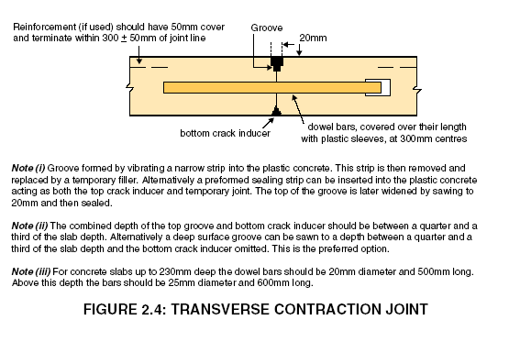

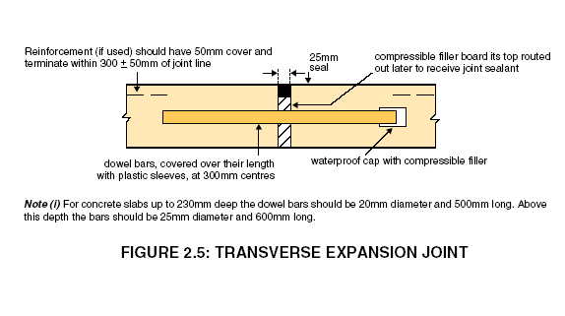

19
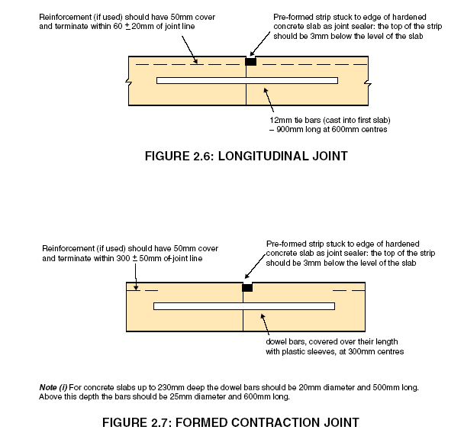
Sawing of joint grooves should be undertaken as soon as possible after the concrete has hardened sufficiently to enable a sharp edged groove to be produced, without disrupting the concrete and before random cracks develop in the slab. This would usually be within 6 to 24 hours after the concrete is poured. The grooves should be between 1/4 and 1/3 the depth of the slab and of any convenient width not less than 3mm. The groove can be widened by sawing at this stage, or later, to accommodate the joint sealant.

Expansion joint filler should be compressible board 25mm thick, for the full depth of the concrete. The top of the filler board should be routed out later, to a depth of 25mm, in order to receive the joint sealant.

Dowel bars and tie bars should be Grade 250 steel, complying with BS 4449 and should be free from oil, dirt, loose scale and rust. Dowel bars should be straight, free of burrs and other irregularities, with the sliding end sawn. Dowel bars should be debonded over their length with a tough, durable plastic sheath of average thickness not greater than 1.25mm. For expansion joints, the expansion space available in the waterproof cap should be 10mm greater than the thickness of the joint filler board.

20
Joint grooves should be sealed with a hot applied joint-sealing compound complying with BS 2499 Type A2 and the finished surface of the seal should be 3mm below the surface level of the concrete.

Other expansion joint filling or sealing materials, or other debonding agents may be used, subject to approval.

- Reinforcement: Where reinforced concrete is used, the reinforcement should be long mesh steel fabric, complying with BS 4483 and should be free from loose mill scale, rust, dirt, oil, paint or grease. The minimum weight of reinforcement should be 2.61 kg/m2. The reinforcement should have 50mm minimum cover from the surface and should terminate between 250 and 350mm from any transverse joint and between 40 and 80mm from a longitudinal joint. The reinforcement should terminate between 100 and 150mm from the edges of the slab. Reinforcing mats should overlap such that the transverse wire of one mat would lie within the last complete mesh of the previous mat and the overlap should be at least 450mm.

2.22 Block Paving Block paving roadways should be constructed generally as shown on Figure
Roadways 2.3. The layout and structural design of the pavement is subject to approval.

The structural design of pavements constructed with clay or concrete block pavers, should comply with the requirements of BS 7533.

Clay and calcium silicate pavers should comply with BS 6677: Part 1, type PB with chamfers. 200 x 100 x 65mm pavers are generally the preferred size.

Concrete block pavers should comply with BS 6717: Part 1, type R. 200 x 100 x 80mm pavers are generally the preferred size.

Horizontal interlock should be given to the paving, either by the use of shaped blocks, or by laying rectangular blocks in a herringbone pattern. At the edge of the pavement, restraint should be provided, in order to prevent the pavers and the laying course from migrating outwards and losing interlock.

Clay and calcium silicate pavers should be laid in accordance with BS 6677: Parts 2 & 3.

Concrete block pavers should be laid in accordance with BS 6717: Part 3.

Laying course sand and jointing sand should comply with gradings C and F in Table 5 of IS 5 respectively.

2.23 Flexible Roadways Flexible roadways should be constructed generally as shown on Figure 2.3 and 2.8

Capping layer and sub-base should extend 450mm beyond the kerbface on each side of the carriageway

The minimum road base thickness should be 150mm, except for dense bitumen macadam road base, which should have a minimum thickness at any point, of 80mm.
21
The Contractor may use either the sub-base, or the road base appropriately strengthened, for construction plant and traffic.

The requirements for so using the sub-base, are set out in clause 2.17. Any damage caused by construction traffic should be remedied, as approved, before laying of the road base. Alternatively, the road base may be used by construction traffic, provided it is increased in thickness by 50mm and surface dressed.

Damage caused by construction traffic should be remedied, as approved, before laying of the surface course. Contaminated materials should be made good by cleaning; if this proves impractical the layer should be removed and replaced.

Roadway surfacing shall be one of the following types:
Type A 60mm minimum thickness at any point, of 20mm nominal size binder course dense bitumen macadam under 40mm minimum thickness at any point, of 14mm nominal size close graded surface course bitumen macadam.
Type B 60mm minimum thickness at any point of 20mm nominal size binder course dense bitumen macadam under 40mm thickness at any point of 14mm nominal sized hot rolled asphalt surface course.
Type C 60mm minimum thickness at any point, of 20mm nominal size binder course dense bitumen macadam under 40mm thickness at any point of 14mm nominal size stone mastic asphalt.

Type B or Type C road surfacing must be used in developments constructed outside the 50 kph speed limit zone

Any widening, overlaying or re-constructing of existing public road should be constructed to appropriate standard of existing public road and/or as instructed by Donegal Co. Council.

All materials to comply with National Road Authority’s, “Specifications for Roadworks.”

22
2.24 Safety Barriers Safety barriers should be provided along road in accordance with the NRA’s Design Manual for Roads and Bridges TD 19/04 in the following circumstances

- On embankments with a slope steeper than 1:3 with a slope height exceeding 2m
- On embankments with a slope of 1:3 to 1:5 with a slope height exceeding 6m.
- At locations where an errant vehicle may encroach onto an adjoining road or private property.

In addition Local Authority approved barriers or safety mechanisms will be required where a footway abuts a steep incline or sudden drop in level.

Landscaping of the area may also be required.

S2.25 Footways Footways should have a sub-base, of minimum thickness 150mm of wetmix material on a suitable capping layer to clause 601 and should be of bitumen macadam or concrete construction. In the former case the surfacing should consist of 60mm minimum thickness of 20mm nominal size binder course dense bitumen macadam and a wearing course of 25mm minimum thickness of 10mm nominal size close graded surface course bitumen macadam, both of which should comply with NRA’s Specification for Roadworks.

Concrete footways should be constructed to a depth of 100mm minimum thickness, increasing to 150mm where there is vehicular access. All such accesses must incorporate sheets of A252 steel mesh “top and bottom ”over the full width of the access. These must have a minimum cover of 30mm with minimum 350mm overlaps. Joints should be formed in a straight line, at right angles to the footway, at a maximum spacing of 3m and each joint should include a double layer of roofing felt, complying with IS 36, for the full depth of the joint. A separation membrane, as specific in clause 2.21 above, must be placed between the concrete and the sub-base. Concrete should be air entrained paving quality as specified in Table 2.6 of clause 2.21.

The minimum footway width should normally be 2m. Where isolated obstructions occur on footways, the minimum clear width at the obstruction should be 1.2m. Clear headroom of 2.2m should be provided across full width of footway. Footways should have a cross slope of 2% and where adjacent to roadways, this slope should be towards the roadway. The footway slope at dished kerbs should not normally exceed 7%.

Uncontrolled pedestrian crossings should be designed and installed in accordance with the National Disability Authority’s Guidelines. Manhole covers, gullies and all other ironwork should be kept clear of pedestrian crossings.

S2.26 Kerbs Kerbs should be laid to a smooth flowing alignment both vertically and horizontally. Kerb face should be 125mm, except at vehicular accesses where they should be reduced to 25mm above the channel and at pedestrian crossing points where an upstand of 6mm should be provided. Pedestrian crossing points should be constructed in accordance with Figure 2.9. At junctions, the footway crossings must be located on the minor road behind the tangent point of the entry radius and enable crossing of the road at right
23
angles. Double yellow lines must be provided on the roadway along the full width of pedestrian crossing.

Dropped kerbs may be achieved using 150X125mm bullnosed kerbs or 250X125mm kerbs provided they are not laid on back. 150X50mm concrete edge kerbs should be used at rear of footway and sides of footpaths of bitumen macadam construction. For radii less than 12m, straight kerbs cut to 300mm lengths should be used.

Precast kerbs should be 250mm by 125mm, complying with IS 146 and should be laid on a 100mm thick by 300mm wide concrete bed and haunch.
Cast-in-situ concrete kerbs should be 300mm deep by 225mm wide, laid on a 100mm sub base which should be haunched. Concrete should be air entrained, as specified in Table 2.6 of clause 2.21 above.
Alternative kerb types at roadway edges are subject to approval and may be required in sensitive locations including historic/conservation areas.

2.27 Cement Cement should comply with IS 1.

2.28 Concrete Aggregates Coarse and fine aggregates from natural sources, for concrete, should
comply with IS 5.

2.29 Traffic Calming Traffic calming measures should be provided in accordance with the requirements of Donegal Co. Council and be constructed in accordance with details outlined in Traffic Management Guidelines published by the Stationary Office Sun Allianz House, Molsworth Street, Dublin 2.

2.30 Wheel Cleaning Mechanical wheel cleaning facilities should be provided and used by all construction traffic exiting the site.

2.31 Cycle Tracks Cycle tracks should be constructed to same standard as footways. Road markings should be provided in accordance with details outlined in the Traffic Sign Manual Guidelines published by the Stationary Office Sun Allianz House, Molsworth Street, Dublin 2.

2.32 Children at Play Signage Children at play signs should be provided on all approaches to open spaces.

24

SECTION 3
SEWERS AND DRAINS

25

Section 3: Sewers and Drains

3.1 Compliance Drainage works should comply generally with the requirements of BS 8005: Part 1, BS 8301 and this document.

3.2 Separate Systems Separate systems are required for wastewater and rainwater. No storm water will be allowed to discharge to the foul sewer.

3.3 Pipe Types The following pipes and fittings may be used for surface water sewers and drains.

- Unplasticized polyvinylchloride (PVC-U) pipes and fittings, in accordance with the requirements of IS 424.

- Spigot and socket concrete pipes, in accordance with the requirements of IS 6.

- Twin walled high density polyethylene pipes and fittings in accordance with the requirements of BS EN 1610:1998

- Glass reinforced plastics (GRP) pipes and fittings, in accordance with the requirements of BS 5480.

- Glass composite concrete (GCC) pipes and fittings, in accordance with the requirements of BS 5911: Part 101.

Joint types and materials are subject to approval. Other pipes and fittings may be used, subject to approval. Under no circumstances are concrete Ogee pipes to be used.

3.4 Pipe Sizes & Performance criteria for protection against surcharge and flooding
Gradients - Surface should be determined by the Applicants Designer and approved by the
Water Local authority
The area to be taken into account should be the total area of the roofs, together with the total area of paving contributing to the pipe system. Paving from which the run-off flows onto permeable surfaces should not be included. Where the run-off from unpaved areas might cause ponding, or contribute significantly to the pipe flows, proposals for such drainage should be determined by the Applicants Designer and approved by the Local Authority.

Surface run-off (l/s) should be calculated by means of the Modified Rational Method (Wallingford Procedure).

Q = A_{p} x i x C_{r} x C_{v} x 2.78

where

Q = Rate of run-off (l/s)
A_{p} = Impermeable area (ha)
I = Intensity of rainfall (mm/h)
C_{r} = Routing coefficent
C_{v} = Volumetric run-off coefficient
26
For areas which require a main surface water drain of up to 200m in length, rainfall intensities (i) of 75mm per hour for roof surfaces and 50mm per hour for paved surfaces may be used. For larger areas, the rainfall intensity/duration/frequency relationship requires to be established, having regard to such local rainfall records as are available.

Recommended storm return periods for the design of drainage pipework, within the context of this publication, are set out in Table 3.1.

TABLE 3.1 Recommended Storm Return Periods for the
Design of Drainage Pipework
_____________________________________________________________

Type of Site Return Period Years
_____________________________________________________________

Sites with average surface gradient greater than 1% 1
Sites with average surface gradient of 1% or less 2
Sites where consequences of flooding are severe 5
_____________________________________________________________

It may be assumed that the maximum discharge of storm water from an area occurs when the duration of the storm is equal to the time of concentration (t) of the area. The time of concentration is the longest time taken for the rain falling on the area to reach the drain, plus the time taken to reach the point of concentration.

t = time of entry + length of drain
full bore velocity of flow

The time of entry may be regarded as representing the delay and attenuation of flow over the ground surface. Time of entry generally lies in the range of 4 to 8 minutes, with the larger figure applicable to a relatively flat subcatchment and the smaller value to relatively steep subcatchments. (Subcatchment refers to the area contribution to each individual pipe length).

Particular conditions may warrant a time of entry outside this range.

The value of the routing coefficient (C_{r}), varies with the shapes of the time-area diagram and the rainfall profile. A value of 1.3 is commonly used.

The value of the Volumetric run-off coefficient (C_{v}), represents the proportion of rainfall on the paved areas that appears as surface run-off in the storm drainage system. The coefficient ranges from about 0.6 on catchments with rapidly draining soils, to about 0.9 on catchments with heavy soils.

Other methods of calculation of the Rate of run-off are subject to approval.

The minimum diameter of surface water sewer should be 225mm. Pipes should be laid at gradients that would produce velocities in the range of 0.8m/sec - 3m/sec, when flowing half full.
27
Subject to the limitations imposed by the foregoing, pipe sizes and gradients should be selected from approved tables for the hydraulic design of pipework.

Any runoff from sloped or grassed areas should be collected and disposed of by filter drains and perforated drainage pipes connected to appropriately sized surface water sewer.

Minimum width of 10m is required for any way-leaves for all services traversing private property. This width may be reduced in certain circumstances only after consultation with Donegal County Council.

3.5 Pipe Sizes & Pipes carrying foul water should be designed to accommodate six times
Gradients – Foul the average foul water flow. Average flow should be taken as 1,000
Sewer litres per dwelling per day. Gradients should be selected so as to maintain self-cleansing velocity under normal discharge conditions and designed so that they are capable of discharging the relevant design flows without causing a surcharge in the system. Twice the average daily flow can be used as the criterion for the self clensing velocity. All pipework should be laid at gradients that would produce velocities lying in the range of 0.75m/sec to 3m/sec, when flowing half full.

TABLE 3.2 Pipe sizes and Gradients – Foul Water
____________________________________________________________
No. of dwellings Minimum Pipe Minimum
Contributing Diameter (mm) Gradient
____________________________________________________________

1 100 1 in 60
2 100 1 in 100
3 or more 150 1 in 150
____________________________________________________________

No single foul drain should serve more than eight dwellings.
The minimum recommended diameter of pipe acceptable for a trunk public sewer is 225mm. Changes in pipe size should only occur at manholes. Different pipe sizes should meet soffit to soffit.
Subject to the limitations imposed by the foregoing, pipe sizes and gradients should be selected from approved tables for the hydraulic design of pipework.

3.6 Bedding & Cover Rigid pipes do not deform appreciably under their design load.
Rigid Pipes Rigid pipe materials exhibit a linear, brittle stress-strain behaviour.

The load carrying capacity of a rigid pipe is dependant on three main factors – the minimum crushing strength of the pipe, the class of the bedding used and the uniformity of the support provided by the foundation along the pipeline.

Bedding and cover requirements for rigid drainage pipes are set out in Figure 3.1and Table 3.3. It should be noted that Class D bedding should not be used, unless accurate trimming can ensure full bearing of the pipe on the trench floor. Class F bedding is generally suitable in all soil conditions, but measures may be required to prevent ground water flow in the trenches, during construction.
28
Selected fill should be free from stones larger than 37.5mm, lumps of clay over 75mm, timber, frozen material and vegetable matter.

Granular material should be either 14mm to 5mm graded aggregate, or 10mm single sized aggregate, complying with the requirements of IS 5: Part 1 1990, Table 7 and should have a Compaction Factor value not greater than 0.2 when measured in accordance with BS 8310: 1985, Appendix D.
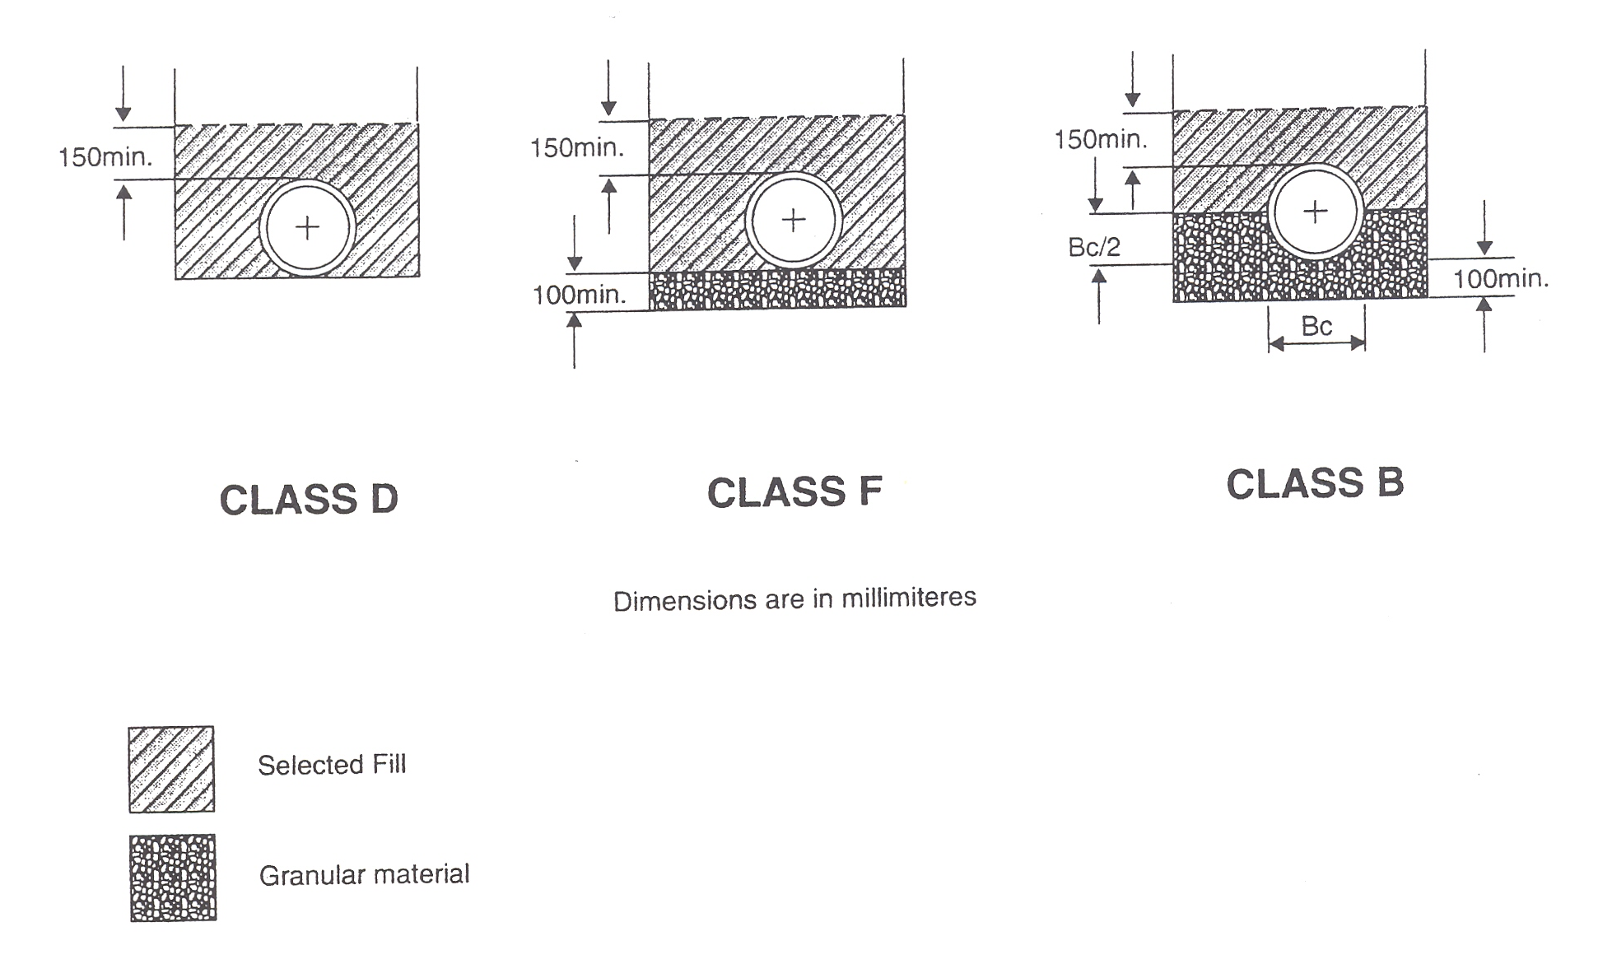
FIGURE 3.1: BEDDING AND SURROUND FOR RIGID DRAINAGE PIPES

TABLE 3.3 Limits of cover in metres for standard rigid pipes in any width of trench
_______________________________________________________________________

Pipe Bedding Min Max Min Max
Diameter Class
_______________________________________________________________________

100mm D 0.6 4.2 1.2 4.1
100mm F 0.6 5.8 1.2 5.8
100mm B 0.6 7.4 1.2 7.4
150mm D 0.6 2.7 1.2 2.5
150mm F 0.6 3.9 1.2 3.8
150mm B 0.6 5.0 1.2 5.0
225mm D - - - -
225mm F 0.6 2.5 1.2 2.1
225mm B 0.6 3.3 1.2 3.2
300mm D - - - -
300mm F 0.6 2.2 - -
300mm B 0.6 2.6 1.2 2.4
_______________________________________________________________________

Pipes laid in open spaces should have a minimum cover of 0.9m.

29
Where it is not possible to achieve the minimum cover stipulated in Table 3.3, pipes should be bedded and surrounded in concrete, 150mm thick, Class E, in accordance with Clause 1502 of the Specification for Roadworks.

For depths of cover greater than the maxima stipulated in Table 3.3, pipes with a higher crushing strength and/or bedding with a higher bedding factor are required, subject to approval.

3.7 Bedding & Cover Flexible pipes deform under load and the extent of this deformation
Flexible Pipes depends upon the stiffness of the pipe and the compaction of the immediately surrounding fill. The materials for these pipes exhibit ductile stress-strain characteristics.
A flexible pipe derives its load bearing capacity from the pipe stiffness and the passive resistance developed in the surrounding materials. Bedding and surround requirements for flexible pipes are shown in Figure 3.2.

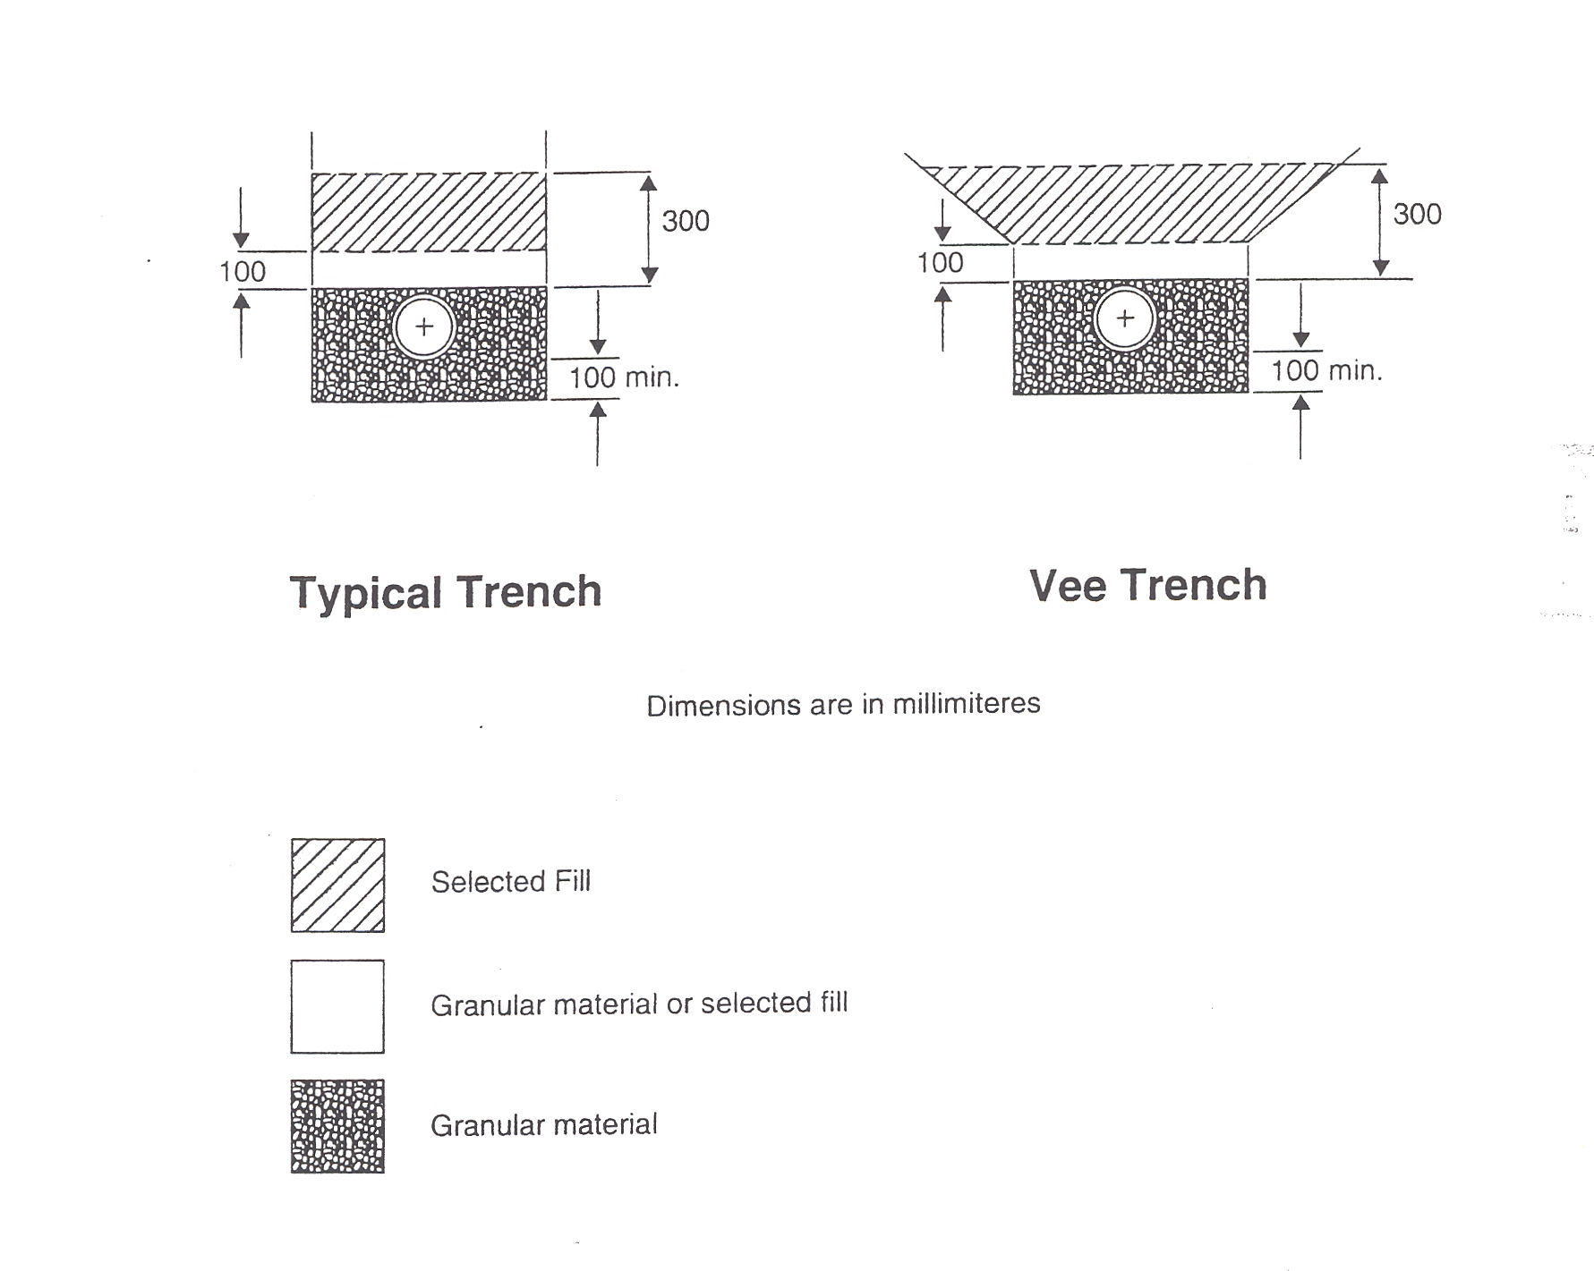 FIGURE 3.2: BEDDING AND SURROUND FOR FLEXIBLE DRAINAGE PIPES

In the case of Vee Trench excavation, a sub-trench should be dug as shown in Figure 3.2. Otherwise, the form of construction is the same as that of the Typical Trench case.

Flexible pipes should be laid with a minimum cover of 1.2m in roads and driveways, 0.9m in open spaces and footpaths not adjacent to roadways and 0.6m in gardens. Where it is not possible to achieve these minimum covers, additional measures should be taken in order to protect the pipework. These measures might take the form of a layer of concrete paving slabs, with at
30
least a 75mm layer of granular materials between pipes and slabs, for gardens and open spaces. In the case of a road, a reinforced concrete surround, or reinforced concrete bridging slabs may be required. All such measures are subject to approval.

3.8 Trench Width The limits of cover specified in Clauses 3.6 and 3.7 are irrespective of trench width.

Trench width at the level of the top of the pipe should generally be as narrow as safe working conditions would allow, with a minimum width of 300mm plus the external diameter of the pipe barrel.

When the trench width exceeds four times the outside diameter of the pipe barrel in the case of rigid pipes, or six times the outside diameter of the pipe barrel in the case of flexible pipes, the granular material may be sloped down from that width to the trench formation.

3.9 Trench Sidefill of either granular material or selected fill, should be placed
Compaction uniformly on either side of the pipe, in layers not exceeding 100mm, each layer being compacted by hand tamping until the pipe has a minimum of 150mm compacted cover. Care should be taken that the process of compaction does not displace the pipe from its correct line and level.

Backfill should be placed in layers not exceeding 300mm, each layer then being well compacted. Mechanical compaction equipment should not be used until there is a minimum of 450mm of compacted material above the crown of the pipe.

3.10 Accessibility The sewer will be located in a public area, primarily in the road. The sewer will be at least 600mm away from other services and no other service will be laid on top of the sewer line.

The sewer pipe should be at least 5m away from buildings and at least 3m from a wall, fence or tree.

3.11 Access to sewers Access to sewers and drains should be provided at maximum intervals of 90m and in the following positions:

      - At all changes of direction
      - At all changes of gradient
      - At the head of all sewer and drain lengths
      - At all sewer junctions and changes in pipe diameter
      - At the point of connection of a branch drain with a main drain or sewer, or on the branch drain within 12m of such connection.

Access should generally be provided by means of a manhole but, subject to approval, a proprietary access junction may be used in lieu of a manhole, on a drain where the depth to invert is less than 600mm.

An untrapped gully at the head of a drain would suffice as an access. Where there is a trapped gully at the head of a drain, it should be provided with a rodding eye, or an alternative means of access, within one meter of the gully.

31
3.12 Drain to sewer Subject to the requirements of Clause 3.11, the connections of drains to
Connections sewers should be made in such a manner as to minimise any interruption of the flow, by one of the following methods:

      - Where there is an adjacent manhole, the connection should be made at the manhole.
      - Where there is not an adjacent manhole, it will be necessary to construct a new manhole.
      - When connecting directly to a sewer or drain, an oblique or curved square junction pipe inserted in the main may be used.
      - As an alternative method to method 3., an oblique type saddle may be used. Saddles should not be used on pipes of 100mm diameter, nor to connect pipes of the same diameter.

In the case of methods 3. and 4., an approved slow bend may be used in the drain, immediately upstream of the connection.

Intercepting traps between drains and sewers should not be used, except where the Local Authority requires them at connections with existing sewers.

All applications for non-domestic connections to the public sewer shall be accompanied by a valid application for a licence to discharge to the public sewer.

For estates a trunk sewer must be laid down all main roads and the individual houses must connect to this via a private inspection/access chamber. The physical connection to the trunk sewer shall be at a manhole or be by the use of proprietary saddle only.

3.13 Joints All pipes should have flexible joints formed by a method recommended by the pipe manufacturer. Elastomeric sealing rings, complying with the requirements of BS 2494, type D, should be used.

3.14 Manhole Manholes should be durable, resistant to water penetration, resistant to
Construction leakage and should be designed and constructed so as to minimise the risk of blockage.

Manholes may be constructed of:

- Solid concrete blockwork, complying with the requirements of IS 20.
- In-situ concrete, 30N/mm², 20mm maximum aggregate size.
- Pre-cast concrete units, complying with the requirements of BS 5911: Part 200.
- Other materials, as approved.

Manhole bases should be constructed of concrete, 30N/mm2, 20mm maximum aggregate size, minimum thickness 150mm for depths up to 3.3m and 225mm for depths in excess of 3.3m. Alternatively, approved precise concrete bases may be used.

The minimum wall thickness for concrete blockwork, or in-situ concrete, should be 200mm for depths up to 3.3m and 300mm for depths on excess of 3.3m.
32
Blockwork mortar should be Class 1 in accordance with Clause 2404 of the Specification for Roadworks. All mortar joints should be completely filled and flush pointed as the work proceeds. Blockwork walls should be scudded and rendered in two coats externally, to a minimum thickness of 20mm. The rendering materials should have a 1:3 cement sand dry volume ratio and should incorporate an approved waterproofing agent. The sand should comply with the requirements of BS 1199.

When a manhole is to be used to provide a drop then the drop pipework shall be placed externally with lean mixed concrete surround. Where drop manholes are to be constructed the base for the manhole should be sized to provide suitable foundation for the supporting lean mix surround to the pipework.

Where pre-cast concrete units are used for the manhole chamber, special attention should be paid to jointing. Where manholes are constructed wholly above the watertable, rebated joints sealed with cement mortar may be satisfactory. In waterlogged ground, or where the water table is above the manhole base, joints should be made water tight, preferably using a non-rigid jointing material such as a mastic sealant, or an elastomeric ring.

Where pre-cast units are installed in unstable ground, or are likely to be subjected to exceptional or eccentric loads, a 150mm concrete surround, 30N/mm², 20mm maximum aggregate size should be provided. Care should be taken to compact the concrete under incoming and outgoing pipes. Any joints in the concrete surround should be staggered with those of the pre-cast units.

Roofs should consist of a reinforced concrete slab, minimum thickness 150mm, designed to carry all live and dead loads. Roof slab dimensions must be compatible with that of accompanying manhole cover frame. Alternatively, Local Authority approved pre-cast concrete roofs may be used.

1 to 3 rows of class B engineering brick complying with IS 91 or concrete bricks complying with IS 189 should be laid as an adjusting course under the manhole frame. The maximum adjusting course depth should be 300mm. All works to be in accordance with NRA’s Specification for Roadworks.

3.15 Manholes Manhole dimensions depend on the size of the main drain or sewer and
Dimensions on the number, size and position of branch pipes entering. The design size should permit entry, without unduly restricting operating space.

Minimum internal dimensions of manholes should be as in Table 3.4. Subject to the minimum sizes given, adequate dimensions may be calculated for straight inverts on the following basis:

- Length: Considering the side with the greater number of branches, provide the sum of the branch diameters plus 200mm per branch for branches up to 150mm diameter (or, 300mm per branch for branches greater than 150mm diameter), plus 300mm.

- Width: Provide 300mm for each benching with branches, or 150mm for a benching with no branches, plus the diameter of the pipe.
33
Manholes with curved channels, or with a difference in level of over 300mm between incoming and outgoing pipes, require special consideration and the dimensions should be subject to approval.

TABLE 3.4 Minimum Internal Dimensions of Manholes
(Pipe Diameter ≤ 300mm)
____________________________________________________________

Depth to Invert Rectangular Circular
(m) Length (m) Width (m) (m)
______________________________________________________________

≤ 1.5 1.2 0.75 1.0
1.5 to 2.7 1.2 0.75 1.2
* > 2.7 1.2 0.84 1.2
______________________________________________________________

* For depth to invert of more than 2.7m, a working chamber and access shaft may be provided in lieu of a full sized manhole for the full depth. The chamber height should be not less than 2m above the top of the benching and its dimensions should be as for the manhole. The minimum internal dimensions of the shaft should be 0.9 x 0.84m (rectangular), or 0.9m diameter (circular)

3.16 Channels An open channel of half – round section, bedded and jointed in 1:3
& Benching cement sand mortar, should extend the whole length of the manhole. Where there is change in pipe size between the main pipe entering and that leaving the manhole, the connecting channel should consist of an approved proprietary taper. Where a suitable taper is not available, the channel should be formed from in situ concrete, 20N/mm², 20mm maximum aggregate size, finished with a 1:3 cement sand mortar.

A vertical in situ benching should be formed from the top edge of the channel, t o a height not less than the soffit of the outlet. It should be rounded off to a radius of about 25mm and then sloped upwards at a gradient of about 1:12 to meet the wall of the manhole. The benching should be floated to a hard smooth surface, with a coat of 1:3 cement sand mortar laid monolithically.

In the case of branch channels, the benching should be so shaped as to guide the flow in the desired direction.

Alternatively, pre-cast base units, incorporating channels and benching may be used, subject to approval.

3.17 Manholes Covers Manhole covers and frames are subject to approval, but should comply
& Frames generally with the requirements of IS EN 124. The minimum opening dimensions should be 675mm x 675mm (rectangular), or 700mm diameter (circular). All manhole covers and frames in roads, footways and grassed areas must conform to IS EN 124 Class D400 or IS 261 Grade A and be locked with a 16mm steel bolt. All covers and frames must be marked with the relevant standard and certification from an approved third party.

Manholes should not be positioned in path of pedestrian accesses.
34

3.18 Manhole Steps Steps should be provided in manholes of between 1metre and 4.5m in
& Ladders depth. Ladders should be used, instead of steps, for manholes deeper than 4.5m. Manhole steps should comply with the requirements of BS 1247: Part 1. Blockwork, in situ concrete and pre-cast concrete manholes should be provided with steps, in two vertical runs, 300mm apart centre to centre. The steps should be at 300mm intervals in each run and the two runs should be staggered vertically, by 150mm. The top step should be a maximum distance of 450mm from the ground surface and the bottom step should be a maximum distance of 300mm above the top of the benching. Precast concrete units should have built-in steps, as provided for in Clause 3.6.5 of BS 5911: Part 200.

Access ladders should be fabricated from steel complying with the requirements of IS EN 10113. Stringers should be not less than 65mm x 12mm in section, 300mm apart and drilled with holes 20mm diameter for shouldered 22mm diameter rungs at 300mm centres. At the top, the stringers should be bent at right angles, to a radius of 150mm and an allowance made for a horizontal run of 225mm before ending in a face plate, for fixing to the manhole wall. Horizontal stays, not less than 65mm x 12mm in section should be provided at intervals not exceeding 2.4m. The ladder and stays should be hot-dipped galvanized, after fabrication in accordance with the requirements of BS 729. The method of fixing the ladder to the manhole wall is subject to approval. The top rung should be a maximum distance of 450mm from the ground surface and the bottom rung should be a maximum distance of 300mm above the top of the benching. Alternative ladder designs may be used, subject to approval.

3.19 Gullies Gullies are required generally, for the collection of surface water from roofs and impervious areas, for discharge into a surface water drainage system. They should be provided for impervious or paved areas at a minimum of one gully per 200m². A sufficient number of gullies should be provided to drain adequately the surface water from the road and the normal spacing of gullies should be 50m centres on both sides of a cambered road and 30m centres on the low side of a road with any crossfall. Additional gullies should be provided at road junctions and cambers/crossfalls should be such as to ensure no water discharges too or from public road.

Road gullies must be fitted gratings conforming to IS EN 124 class C250 and incorporate a locking mechanism approved by the Local Authority.

Gullies should not be positioned in path of pedestrian and vehicular accesses. Gully and grating must be positioned tight against the kerb with the grating placed directly over the gully to facilitate cleaning. Gully gratings in roads should be set with the direction of the openings at right angles to the direction of traffic. Top of gully grating should be positioned 10mm below finished road surface.

Gullies for the collection of roof water and for the drainage of small paved areas other than roads should be clayware, complying with the requirements of BS 65. Other types of gully may be used, subject to approval. Rainwater downpipes should either discharge over an open gully fitted with a grating, or be connected to the back inlet of a back inlet gully. The maximum distance from finished ground to the bottom of the gully, should be 600mm.

35
Gullies for the drainage of roadways and large paved areas should be pre-cast concrete, complying with the requirements of BS 5911: Part 230, or may consist of a chamber constructed of 100mm solid blockwork and having a 150mm in-situ concrete floor, with minimum internal dimensions of 450mm x 300mm x 750mm. The outlet from the gully should be 150mm diameter, set a minimum of 375mm above the floor of the chamber. The type of gully is subject to approval.

3.20 Testing of Sewers Main pipelines shall be air or water tested and conform to the requirements of the latest version of B.S. 8005 Part 1 or equivalent.
On completion of construction works, all pipelines intended for taking in charge shall be thoroughly cleansed and all deleterious matter removed. The Developer shall maintain them in a clean and serviceable condition until the Local Sanitary Authority takes them in charge.
The Developer in the presence of the Local Sanitary Authority shall test all main pipelines after they are jointed and before any concreting or backfilling commences. Pipelines shall be tested by means of an air or water test, refer to the latest version of B.S. 8005 or equivalent. A further test may be required after the backfill is complete.

1. Water Test: Pipes and manholes are to be filled to 1.2 metres above the crown at the high end of the line. The rate of loss of water should not be greater than 1 litre per hour, per metre diameter, per metre of pipe run.

2. Air Test: Pipes are to be tested to 100mm of air pressure for 5 minutes duration. A max drop of 25mm is allowed.

Any pipelines that are defective will have to be rectified by the Developer at their own expense and the survey will then have to be repeated to the satisfaction of the Local Sanitary Authority.

3.21 Manhole Manholes shall be tested on completion of construction by means of a
Infiltration water test. In all cases manholes must be watertight. Groundwater infiltration into pipelines or manholes is unacceptable.

Infiltration tests should be carried out on manholes after backfilling, when the groundwater adjacent to the manhole is at its highest level.

Any manholes that are defective will have to be rectified by the Developer at their own expense and the survey will then have to be repeated to the satisfaction of the Local Sanitary Authority.

3.22 Cleaning & At the time of completion of the development works, the developer
Surveying of should ensure, to the satisfaction of the local authority, that all sewers
Sewers, Drains and drains within the site are clean and free from obstruction. A
& Manholes manhole condition inspection survey and CCTV survey of foul and surface water sewers should be submitted for approval of Local Sanitary Authority. The reports must conform to the standards set out in the WRC manual of Sewer Condition Classification, fourth edition and the survey must be submitted in mpeg format.

36

3.23 Sewer Diversions No sewer shall be diverted, re-laid or altered without the express written permission of the Local Sanitary Authority. Proposal for sewer diversions including all necessary future wayleaves should be submitted to the Local Sanitary Authority for written approval. Any diversion shall not adversely affect the hydraulic capacity or maintenance of the sewer.

The Developer shall arrange at their own expense to have a sewer condition survey (CCTV) carried out on the sewer that is to be diverted, to the requirements of Local Sanitary Authority. Any connections, whether live or currently unused, must be accommodated within the development and then re-connected to the active diverted sewer.

Abandoned sewers must be grubbed up or filled with concrete and disused connections properly sealed to the approval of the Local Sanitary Authority.

Ownership of newly diverted sewers and associated wayleaves must be transferred to the Local Sanitary Authority upon satisfactory completion of construction.

3.24 Grease Removal A Grease Recovery Unit (GRU) must be fitted on the outlet from all kitchen sinks within Food Services Establishments (FSE) subject to the requirements of the Local Sanitary Authority. They must also be fitted on any commercial scale food preparation locations.

Grease Traps should comply with the latest editions of the following:
- EN 1825-1 : 1995, or equivalent, Principles of design, performance, testing, working and quality control.
- I.S. En 1825-2 : 2002, or equivalent, Selection of nominal sizes, installation, operation and maintenance of grease traps.

The Local Sanitary Authority encourages the use of appropriate grease removal systems on the waste discharge from kitchen waste outlets in domestic dwellings. This is to prevent Fats Oils and Grease, FOG, from entering the public drainage system.

The use of, under sink food macerators/food grinders for processing and discharging waste food to the drainage system is prohibited.

37

3.25 Pumping Stations Due to the wide variation in pumping stations, this section covers the main requirements for their installation. However, the Developer must contact the Local Sanitary Authority to ensure compliance with their detailed requirements as outlined in Appendix B.

The Local Sanitary Authority must give written approval to the location and design of any proposed pumping station. In general pumping stations should be of the Wet Well design. Access to the pumping station should be via a 4m paved roadway linking to the public road to allow for future maintenance of the station. Detailed design should be in accordance with the Local Sanitary Authority’s requirements in Appendix B.

The pumping station must be fully commissioned and made operational, by the Developer, to the specific requirements of the Local Sanitary Authority. Details and specifications of all electrical equipment, including the control panels and standby generators should be submitted to the Local Sanitary Authority for written approval and should be in accordance with the Local Sanitary Authority’s requirements in Appendix B.

3.26 Rising Mains The Local Sanitary Authority shall approve the pipe material and the rising main configuration.
A surge analysis is to be carried out and if necessary surge vessels or other pressure release devices must be used if required.
Testing shall be in accordance with the Local Sanitary Authority requirements.
An approved vent must be provided at the connecting manhole.
An approved flow meter must be installed on the rising main.

3.27 Wastewater New developments are required to connect to the public sewerage
Treatment Plant system where options to do so exist. The specification for Wastewater Treatment Plants is contained in Appendix C.

38

- SECTION 4
- WATER SUPPLY

39

- Section 4: Water Supply

- 4.1 Supply Any person requiring a new or additional water supply should first contact the Local Sanitary Authority to ascertain if a water supply is available. Applications for water main extensions must be made at least 1 month in advance of commencement of works on site. All works must be completed before applying for a service connection. Connections will be made by the Local Sanitary Authority at the expense of the applicant. The applicant shall be invoiced for the works and all payments (including any contributions due under the Planning and Development Acts) must be made in advance to the Local Sanitary Authority. The Local Sanitary Authority does not accept liability for fluctuation in supply pressure or volume.
Every new premises whether commercial or domestic must have a separate water service connection. A connection may not be taken from an existing service.

- 4.2. Watermain Pipes No materials shall be used without the prior approval of the Local Sanitary Authority. It is the responsibility of the Contractor to ensure that all materials/fittings to be used on a site have been approved for use by the Local Sanitary Authority in advance of work commencing.
        - Water pipes shall only be MoPVC, MDPE, Steel, Ductile Iron, PVC-A, PVC-U or Polyethylene. All plastic water pipes shall be blue in colour.

- 1 MoPVC pipes shall conform to the UK Water Industry Specification No. 4-31–08 and manufacturers shall operate a quality system in compliance with BS 5750 Part 2 (EN29002).

- 2 MDPE pipes should be of type PE-X-80 and have an SDR rating of 11. They shall conform to the UK Water Industry Specifications:
- a) No. 4-32-03 for pipe sizes greater than 63mm OD.
- b) No. 4-32-04 for fusion joints and fittings.

- 3 Ductile iron pipes shall conform to Class K9 of EN 545. Ductile iron fittings shall be either Class K9 or K12. Ductile Iron pipes and fittings shall be cement mortar lined with 3 sulphate resistant cement and shall be sealed with an approved bitumen or epoxy resin sealcoat.

- 4 Steel pipes shall conform to BS EN 10224.

- 5 Polyethylene pipes shall conform to BS 6572 and BS 6730

- 6 PVC-U pipes shall conform with the requirements of the Provisional Specification of the Department of Local Government for Unplasticized PVC Pipes for Cold Water Supply.

- 7 PVC alloy pressure pipe and fittings shall conform to BS PAS 27.

Fittings and specials should be subject to approval.

40

- 4.3 Service Pipes Service pipes should be minimum 12mm internal diameter and should be
and Fittings some of the following types, unless otherwise approved:

- 1 MDPE pipe and fittings should be of type PE-X-80 and have an SDR rating of 11. They shall conform to the UK Water Industry Specifications:
- a) No. 4-32-02 and/or BS 6572 for pipe sizes up to 63mm OD.
- b) No. 4-32-04 for fusion joints and fittings.

- 2 Polyethylene pipe, type 32, heavy gauge, to the requirements of IS 134.

- 3 Polyethylene pipe, type 50, to the requirements of IS 135.

Each dwelling shall have a separate service pipe which shall be laid without mechanical joints from the Boundary Box to a stop valve inside the house and contained within a 50mm duct along the entire length with 450mm minimum cover to finished ground level. Stopcocks to be located in airtight anti-siphon Tall Boundary chambers minimum 400mm deep, incorporating 1 ¾” female treaded inlet with bung for future manifold meter if required. These are to be installed on the footpath or in the absence of a footpath on the public road and be of a type approved by the Local Sanitary Authority. Boundary box covers shall comply with the requirements of I.S. E.N. 124 or I.S. 216.
Before any house service is covered in, it must be inspected and tested up to the saddle band in the presence of a representative of the Local Sanitary Authority.

No service shall be laid across a road unless otherwise approved by the Local Sanitary Authority in writing.

Fittings and specials will be subject to approval.

- 4.4 Watermain Pipe Watermain pipe size and layout should be designed in consultation with the
Size and Layout Local Sanitary Authority. However, the following general design criteria should apply:
- a) The minimum nominal pipe size shall be 100mm in housing developments of up to 50 houses and shall end in a dead end with a scour valve. Developments of 50 to 100 houses shall have a 150mm diameter spine main with 100mm diameter loops.
- b) The minimum pipe size shall be 150mm in industrial or commercial developments.
- c) Looped water mains shall return to the spur main downstream of a sluice valve.
- d) Water mains shall not be laid under walls or areas designated for trees/shrubs/flowers.
- e) The location of hydrants shall be such that they can be accessed in an emergency. Hydrants should not be located in roads or parking areas.
- f) Sluice valves shall be laid at locations to be agreed with the Local Authority.
- g) No pipe, cable, conduit or other service should be laid longitudinally over the line of a watermain

- 41

- 4.5 Location of Watermains shall be located in accordance with figure 2.2.2.
Watermains The watermain shall be at least 600mm away from other services and no other service will be laid on top of the main. The watermain shall be at least 10m from any Buildings (unless otherwise agreed with Local Authority) or Wastewater Treatment System and at least 2.5m from a wall, fence or tree. These standards shall apply to new watermains and new buildings adjacent to existing water mains unless otherwise approved by the Local Sanitary Authority in writing at pre-planning stage having regard to technical design safeguards. These standards also apply to the construction of structures adjacent to existing water mains.

- 4.6 Pipe Cover The cover as measured from finished ground level to the top of a water main pipe shall be 900mm in footpaths or verges and 1000mm in trafficked areas.

- 4.7 Pipe Laying Open ends of all pipes shall be kept plugged until laid. The trench width shall be pipe diameter plus 100mm subject to a minimum of 300mm and the trench bottom should be free of hard objects such as stones.
      - Pipes should be laid on a 50mm bed of fine-grained material, consisting of sand, gravel or soil, passing the 10mm sieve. Where pipes are laid on rock, bedding material depth should be increased to 100mm. Similar material should be placed around or over the pipe for a cover of 100mm. (Pipes laid under roads should have cover materials increased to 150mm).
All pipes shall be examined internally for dirt, stones, or any foreign matter and shall be thoroughly cleaned before laying in final position. To prevent foreign matter or vermin entering the main as it is being laid, all open ends of laid pipes shall be plugged until the next pipe is ready for insertion.
- In ground that contains ashes or chemicals or material that could accelerate corrosion or deterioration of the pipe, the material to be used and method of laying shall be agreed in writing with the Local Sanitary Authority prior to laying.
- All trenches in or near roadways shall be backfilled with DOE Clause 804 or 806 and in compliance with the Guidelines for the Opening, Backfilling and Reinstatements of Trenches in Public Road. No concrete shall be used in trenches.
- Mechanical compactors should not be used until the total depth of backfill over the pipe exceeds 450mm.

- 4.8 Pipe Jointing Joints should be formed by an approved method, recommended by the manufacturer. Elastomeric sealing rings, where used, should comply with the requirements of BS 2494.

- 4.9 Marker Tape Install an approved marker tape containing a tracer wire. This should be laid 500mm above the water main.

- 42
- 4.10 Pipe Anchorage Gentle curves may be formed in the pipeline by angular deflection of the pipe joint. The angular deflection of each joint shall not exceed 2 degrees, or the manufacturers recommendation if less than 2 degrees. At the locations detailed below where the pipe needs to be restrained against movement under pressure concrete thrust blocks shall be provided.
- Thrust blocks must be designed in accordance with CIRIA Report 128 ‘Guide to the design of thrust blocks for buried pressure pipelines’ and constructed from grade 35/20mm concrete in undisturbed ground having regard to both the pipeline thrusts developed during operation pipeline testing conditions and operations and surge pressures. Thrust blocks are therefore required at each;
  - • Tee-junction,
  - • Bend,
  - • End cap,
  - • Abrupt change in vertical or horizontal alignment,
  - • Duck foot hydrants
Support blocks are required where pipes are laid above ground due to rocky or swampy conditions. They are also required to anchor pipes where gradients are 1:6 or steeper. Design of supports and joints should allow for longitudinal movements due to thermal effects and thrusts due to internal pressure. Design and dimensions of thrust blocks should be indicated on construction drawings.

- 4.11 Sluice Valves Sluice Valves shall comply with the relevant requirements of BS5163. They shall be double flanged. The body, gate and gland shall be cast iron, spindles bronze while sealing rings on gates shall be gunmetal, stainless steel or ductile iron resilient seal gate valves. The number of turns (n) to open/close the valve shall be: n = 2N+1 where N is the nominal diameter of the main in inches.
They shall CLOSE BY TURNING ANTICLOCKWISE. For high unbalanced pressures, a bypass should be provided to the valve, e.g. a DN100 bypass is normally provided for a DN800 valve. To minimise difficulties the valve should be 5/8 to 3/4 the size of the pipeline. Long tapers should also be provided on the downstream to avoid high head loss.

- Location of Sluice Valves
A Sluice valve is to be installed at the start of each branch main at the point of connection with the trunk main in the development. The depth of the sluice valve spindle cap from ground level shall not exceed 600mm. For greater depth an extension with guides at 450mm c/c shall be securely fixed to the sluice valve spindle. (General arrangement of valves to be agreed with the Local Sanitary Authority).

- 43

- 4.12 Hydrants Hydrants shall be manufactured in accordance with EN 14339 and incorporate a round threaded outlet complying with the requirements of BS 750. Hydrant valves shall CLOSE BY TURNING SPINDLE IN A CLOCKWISE DIRECTION. A 100mm drain shall be provided from chamber to surface water sewer. A frost plug shall be fitted to hydrant. Hydrants (which are provided for emergency supply) may not be used for any other purpose without the written permission of the Local Sanitary Authority.

                - For housing developments with units of detached or semi detached houses of not more than two floors hydrants shall be provided so that no house is more than 46m from a hydrant. The water supply shall be capable of delivering a minimum of 480 litres per minute through any single hydrant with residual mains pressure of 1.7 bars at full fire flow discharge. This fire flow shall be sustainable for not less than 30 minutes simultaneously with peak daily water demand. Static storage in lieu of the above shall be not less than 60,000 litres.

                - For Multi occupied housing developments with units of more than two floors the water supply shall be capable of delivering a minimum of 1,200 litres per minute to 2,100 litres per minute through any single hydrant with residual mains pressure of 1.7 bars at full fire flow discharge. This fire flow shall be sustainable for not less than 30 minutes simultaneously with peak daily water demand. Static storage in lieu of the above shall be not less than 63,000 litres.

Where static storage is provided the position of the tank, access to the tank for fire appliances and to the water supply contained therein shall be agreed in writing with the Chief Fire Officer. An open source such as a river or lake may, at the discretion of the Chief Fire Officer, be acceptable in lieu of static storage.

  - Location of Hydrants
Hydrants shall be provided on a hard surface so that no house or part of house is more than 46m from the hydrant. They shall be installed on a main of diameter of not less than 100mm and shall be 300mm below finished ground level. A tolerance of 100mm is permitted. Hydrants shall be positioned so that the area within one metre of the hydrant is clear of obstructions and so that the hydrant shall not be obstructed by the parking, loading, unloading of vehicles or by other activity. All hydrants shall be a minimum of 6m from a building. Hydrants serving non-domestic properties shall be subject to the approval of the Chief Fire Officer.

44
- 4.13 Air Valves Air valves shall be Double Air Valve type with isolating valve. Double air valves shall have bodies and covers of cast iron to BS EN 1561 with flanged inlets of the size specified below. Valves shall be flanged and drilled to BS 4504-3.1. Each valve shall have a large and a small air escape orifice with an isolating valve. The isolating valve shall be a resilient seated gate valve to BS 5163 Type B (BS EN 1074) and shall be of the boltless lever type design. The inlet diameter shall be in accordance with the following table:

- Diameter of Main | - Up to 200mm | - 225mm to 350mm
- Diameter of Branch | - 50mm | - 75mm
- Bore of Valve Inlet | - 50mm | - 75mm
- Min clear opening of surface box | - 450mmx300mm | - 580mmx300mm

- Location of Air Valves
Install Air valves at high points on main trunk unless a service connection exists within 2m of the summit and each branch off the main line. A minimum clearance of 200mm shall be provided around the air valve lever. All air valves should ensure that no ingress of foreign matter can occur. (General arrangement of valves to be agreed with Local Authority).

- 4.14 Stopcocks All service pipes (both domestic and commercial) shall include the installation of a boundary box with suitable cover and integral stopcock into which devices can be placed to control or measure the water supply entering a property (screw-down meter type). The Local Sanitary Authority shall be consulted in relation to approved types of boundary boxes.
CLOSING OF THE STOPCOCK SHALL BE CLOCKWISE. The cover shall be level with the finished ground level after permanent reinstatement. The box shall be located in the footpath fronting the property being served and 225mm from the outside of the boundary.

- 4.15 Valve Chambers Solid blockwork, brickwork or precast chambers 450mm x 300mm x 450mm may be used subject to approval. Valve chamber shall be drained into surface water system using a 100mm drainage pipe.

- 4.16 Surface Boxes Sluice Valve Surface Boxes: Ductile Iron 100mm diameter clear opening 200m deep.
Hydrant Surface Boxes: Ductile Iron 375mm x 225mm x 150mm deep with appropriate identification mark on cover and painted canary yellow.
Air Valve Surface Boxes: Ductile Iron 450mm x 300mm x 150mm deep Cover to be perforated.

All covers and frames must conform to IS EN 124 Class D400 or IS 261 Grade A and be marked with the relevant standard and certification from an approved third party.

Surface boxes shall be bedded in mortar on the chamber walls and, where the chamber is located other than on a footpath, driveway or carriageway shall be surrounded by 150mm concrete, 100mm thick, Grade C30.

45
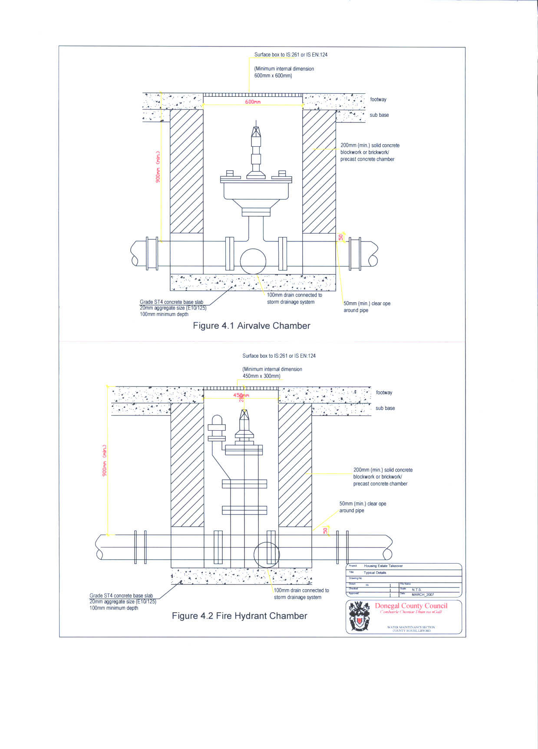

46
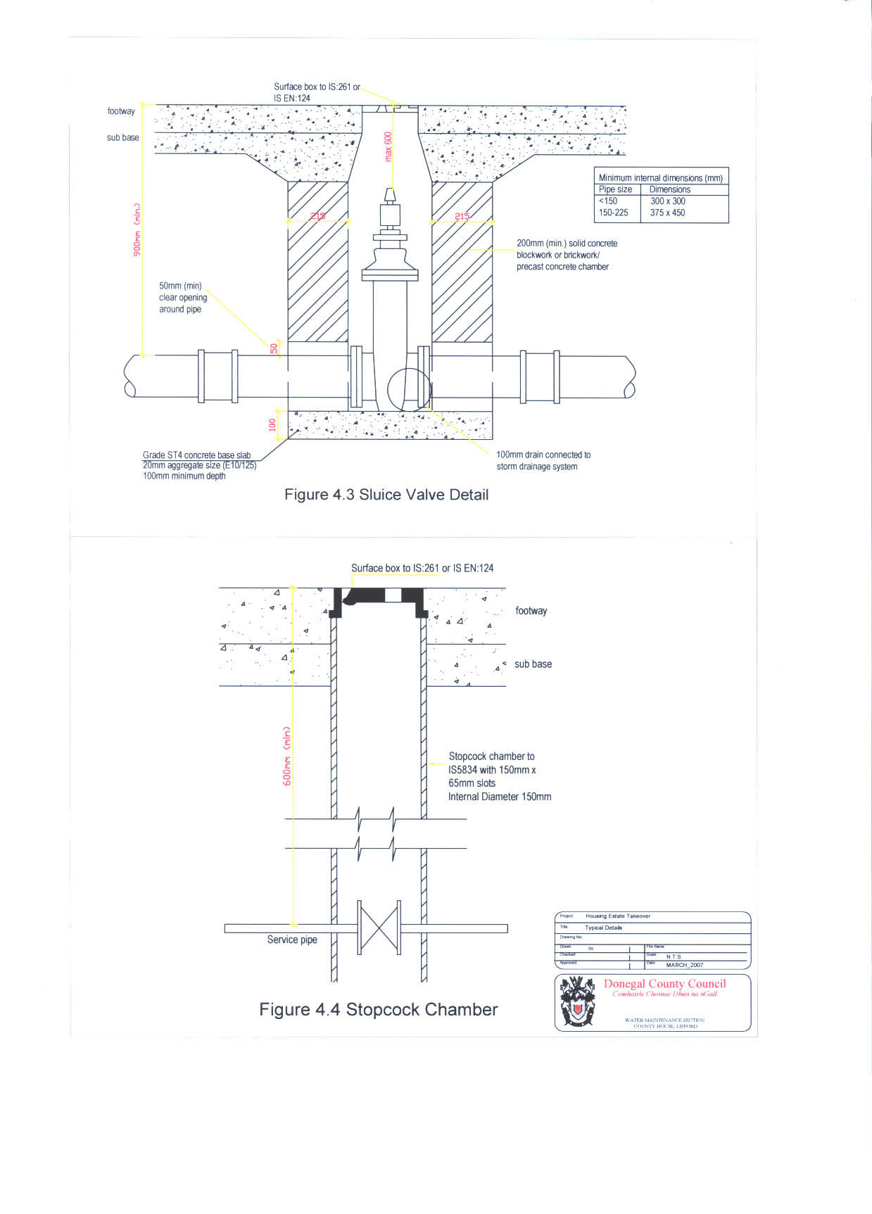

47
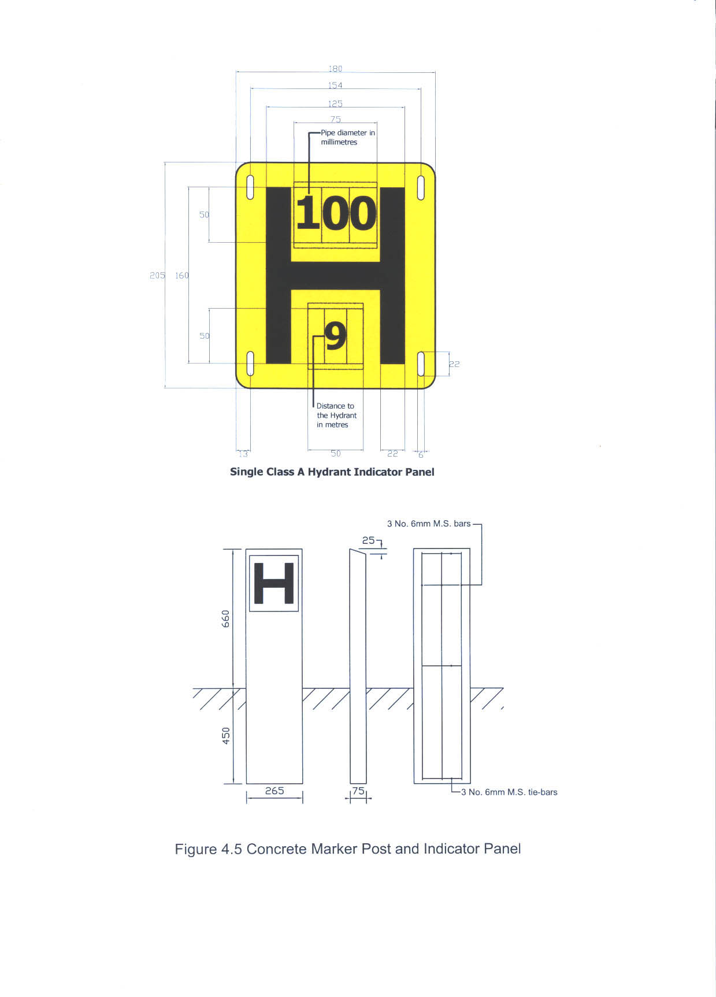

48

- 4.17 Indicator Plates The location of hydrants, air valves, and sluice valves should be shown by
and Marker Posts indicator plates positioned to the approval of the Local Sanitary Authority and shall comply with B.S.3251. They shall be mounted at the back of footpath or in the boundary wall of the public thoroughfare nearest to the hydrant or valve.

Hydrant plates should comply with the requirements of BS 3251. They should show the diameter of the watermain in millimetres on the upper part of the plate and the distance of the marker from the hydrant on the lower part of the plate, as set out in Figure 4.5. All characters should be black and the remainder of the front face should conform to colour reference No. 309 (canary yellow) of BS 381C.

Air valve and sluice valve indicator plates: shall comply with the specification for single hydrant indicator plates with fixed letters in BS 3251 except that they shall be coloured white and, instead of the letter H, shall bear the letters AV and SV respectively as approved.
Indicator and Marker posts shall be of type approved by the Local Sanitary Authority.

- 4.18 Testing All watermains should be hydraulically tested after laying, for a period of
and Sterilization between 1 and 24 hours as approved, at a test pressure of 1.5 times the specified class pressure. The pipeline should be adequately anchored or restrained, during the test.
A test pump, with stopcock, water tank and pressure gauge is connected to the watermain and operated until the gauge shows the required test pressure. (If it is considered necessary, the calibration of the pressure gauge should be validated just prior to the test.) The amount of water in the tank is noted at the beginning of the test period. An hour later, gauge pressure is inspected and if it has fallen, test pressure is restored by means of the pump. This process is repeated at hourly intervals, during the test period. The total quantity of water pumped to maintain the pressure during the test is termed “the apparent leakage”.
The apparent leakage should not exceed 0.11 litres per millimetre of nominal pipe diameter, per kilometre of length, per 24 hours.
An alternative test procedure may be approved, in consultation with the Local Sanitary Authority.
Should pipelines fail this test, remedial works should be to the approval of the Local Sanitary Authority.

- 4.19 Inspection A Local Sanitary Authority representative may inspect the work from time to time. The connection to a Council main will only be given a completion certificate enabling commencement of use when the Local Sanitary Authority is satisfied that:
- (a) The water mains and service pipes have been laid and tested in accordance with this Specification.
- (b) Pressure, chlorination, and bacteriological tests have been carried out and approved.
- (c) A copy of the bacteriological test report has been submitted and approved by the Local Sanitary Authority

- 4.20 Authorised Under no circumstances shall a connection be made to a water main by
Personnel anyone other than the Local Sanitary Authority, notwithstanding the fact that the main may be laid in private property or not be in charge.
49

- 4.21 Scour Valves Scour valves shall be flanged and have the following diameters:

- Diameter of Main (mm) | - Diameter of Scour (mm)
- Not exceeding 75 | - 50
- 100 to 200 | - 75
- 200 to 600 | - 100
- 600 to 800 | - 150

- Location of Scour Valves
Install Scour valves at the lowest point of the water main and at the extreme end of the water main, past the last house in the site and scour into the sites storm drainage. (General arrangement of valves to be agreed with the Local Sanitary Authority).

- 4.22 Meters Each Development shall supply and install a Water Flow meter and construct of a meter chamber 1.2m x 1.2m chamber with heavy-duty circular hinged third party certified cover. The pipe work will be reduced to the diameter of the meter for a distance of 1000mm on each side of the meter, using long all flanged Ductile Iron Pipe. This chamber is to include a 100mm drain to site storm drainage. Meter type to be prior agreed in writing to the Local Sanitary Authority. Meters shall include a suitably approved Y – strainer. Meters shall have the following diameters:

- Diameter of Main (mm) | - Diameter of Meter (mm)
- 100 | - 80
- 150 | - 100
- 200 | - 150

A Sluice Valve shall be installed upstream of bulk meter and down stream. The Sluice valves should be located outside the meter chamber allowing adequate anchorage should the meter require removing. These should be suitably marked with a marker post and plate.

4.23 Pressure PRV’s shall be installed as directed by Donegal County Council and Reducing will be direct double acting diaphragm type. PRV shall include an
Valve approved Y-strainer. A Sluice Valve shall be installed upstream and down stream of pressure reducing valve. These should be suitably marked with a marker post and plate.

- 50
- 4.24 High Level Role of the Designer
Developments It is the responsibility of the designer to ascertain whether or not the
and Buildings Local Sanitary Authority’s water mains have sufficient capacity to meet the requirements of the proposed installation. The Council may, at the expense of the designer or client, carry out pressure and flow tests to permit the designer to calculate the hydraulic capacity of the Local Sanitary Authority’s water mains and so decide on their suitability or otherwise, for the proposed installation.
It is also the responsibility of the designer to ensure that any boosting proposal is sufficient to meet the requirements of the development, subject to any conditions the Local Sanitary Authority may impose to protect the public water supply. Although there may be sufficient flow and pressure at the boundary of the site to serve the proposed development without internal boosting the designer must include a margin for future demands on the system.

- Installation of Booster Pumps
These notes are intended as a guide outlining the Local Sanitary Authority’s policy on the installation of pumps for boosting pressure within a building/development. For multiple building developments see Appendix A.

- Multiple Occupancy Buildings
The service manifold for each separate unit shall be located in the footpath outside the building at a location agreed by the Local Sanitary Authority. In general:-
- (a) Buildings of 3 storeys or more shall be equipped with balancing tanks and booster pumps on the rising main to top storey units to ensure adequate pressure to top storey units.
- (b) Only indirect pressure boosting will be permitted i.e. pumping from a break cistern supplied from the public water main.

- System Maintenance
The designer must supply to the development owner and/or management company full details of the booster system and if applicable the break tank installation. These details should include a recommended maintenance schedule for the system including cleaning of the break cistern.

- Submission of Plans for Approval
Before installing booster pump(s) full details of the proposed installation must be submitted to the Local Sanitary Authority for approval. All booster pumps in excess of 10-litre/min capacity must be fed from a break cistern. The effective capacity of a break cistern should be decided after due consideration of the total water storage requirements and its’ location within the building but should not be less than 30 minutes pump output unless otherwise approved by the Local Sanitary Authority in writing.
- Details to be submitted shall include:-
- (a) Full plumbing layout of the building indicating pipe sizes, storage tank capacity, flow locations of draw off points etc.
- (b) Pump details including valve arrangements, pump size and flow pump curve(s) with the operating point(s) clearly indicated.
- (c) Volume, location and dimensions of break cistern(s).
- (d) Maintenance schedule for the system, - pump inspection/maintenance and tank cleaning.

- 51
    - Break Cisterns

                - A break tank or break cistern shall,
  - (a) be a closed vessel having a tightly fitting access cover bolted or screwed in position
  - (b) be suitably maintained – i.e. inspected and regularly cleaned – and where necessary, suitably lined or coated to preserve the potability of the water;
  - (c) have an air inlet and an overflow pipe or pipes all suitably screened;
  - (d) where necessary, be insulated against heat and be supplied exclusively from a service pipe, via a ball valve.

- 4.25 Notification Where pipes or ducts are to be laid close to an existing water main the Local Sanitary Authority, must be notified in writing a minimum of one week in advance of the works. In case of large diameter (300mm or greater), the water section must be notified one month in advance of the works. These notification requirements are in addition to any the formal procedures detailed above.

- 4.26 Liability for Care must be taken while laying pipes/ducts so as not to damage any
Damage to water main or fitting. Any damage must be immediately reported to the
Existing Mains Local Sanitary Authority and anybody attempting to repair such water main or fitting will be liable to prosecution.

- 4.27 Transportation Suitable pipe supports shall be used on vehicles transporting pipes to
  - and Storage prevent damage to both internal and external coatings by scratches etc. Timber supports are needed during transportation and stacking on site. (Pipes should not be stored in areas where grass is likely to grow due to the risk of grass fires that may damage the stored pipes in due course.)
Use wide fabric purpose-made slings or suitable designed machine for lifting pipes during off-loading and/or laying pipes (particularly flexible pipes with concrete or cement-mortar linings) to avoid scratches to coatings and damage to pipe ends. Damaged pipes may not be used.

- 4.28 Wayleaves If any service is passing through private property, proof of approval
and Easements for wayleave / easement rights should be obtained in advance of notification to the Local Sanitary Authority and submitted with the planning application and water connection application. Minimum width of 10m is required for any way-leaves for all services traversing private property. This width may be reduced in certain circumstances only after consultation with Donegal County Council.

- 4.29 Water Storage Only indirect plumbing systems shall be permitted by the Local Sanitary Authority i.e. all appliances shall be plumbed from a cold-water storage tank and supplied by gravity.
The minimum water storage requirement for new developments is 500 litres per dwelling house or Apartment.

52

- 4.30 EEC Directive Nothing stated in this Specification is to be construed as discriminating
  - on Pipes and against products and materials manufactured in any of the Member
  - Fittings States of the European Community.
Where items to an Irish Standard Specification, a British Standard Specification, or any other Standard Specification of a Member State of the European Community are called for, this requirement shall be read as including items to a relevant international standard, or the relevant national standard of any Member State of the European Community, which provides an equivalent guarantee of safety and suitability.
Where items certified by the National Standards Authority of Ireland as complying with an Irish Standard are called for, the provisions of Circular Letter BM2/97 shall apply, i.e. the requirement shall be read as either certified by the National Standards Authority of Ireland as complying with the Irish Standard, or shall be certified as complying with a relevant international standard, or with the relevant national standard of another Member State of the European Community, which provides an equivalent guarantee of safety and suitability.

4.31 Contacts Water Maintenance Section, Donegal County Council, County House,
Lifford. Tel (074)9172222

53

- SECTION 5

PUBLIC LIGHTING

54

Donegal County Council
Road Lighting Policy
For
Residential Developments
THIS SECTION REPLACES SECTION 5 IN THE “RECOMMENDATIONS FOR SITE DEVELOPMENT WORKS FOR HOUSING ARAS” DOCUMENT PUBLISHED BY THE DOELG, NOVEMBER 1998

5.0 GENERAL

This policy outlines the requirements of Donegal County Council regarding the
provision of road lighting in housing areas. All such road lighting shall comply, in full,
with the following lighting policies of the Council:

5.1 LIGHTING STANDARD

5.1.1 Lighting Design
• The lighting shall be designed by a suitably qualified lighting designer.
• The lighting shall be designed to Irish Standard IS EN 13201.
• White Light Sources shall be used in conjunction with the listed exceptions in
section 5.1.3.
• Light Pollution Levels shall comply with the Attached Schedule: DL-LP, and
shall be in accordance with the Public Lighting Zones identified in the Map: DLPLZ
• The Lighting Class shall be as per the attached Schedule: DL-LC, and shall be in
accordance with the Public Lighting Zones identified in the Map: DL-PLZ
• Calculations shall be submitted to verify achievement of appropriate standard
(Class).

5.1.2 Light Source (lamps)
• (White Light Source) 40w/55w PL-L (CFL) lamps only shall be used.

5.1.3 White Light Exceptions
• 70w SONT require prior approval** and shall only be approved where the need for
SONT lighting is demonstrated.
• Metal Halide or CDM/T lamps require prior approval** and shall only be approved
in exceptional cases.
• 55w SOX lamps require prior approval** and shall only be approved for alterations
or extensions to existing schemes.
• All other Non-CFL lighting requires prior approval**.
** prior approval means approval in writing from the relevant Donegal County
Council ROADS section. This approval must be obtained before any development
works take place.
5.2 LIGHTING LAYOUT

5.2.1 Minimum Clearances Required

Many accidents involve a motor vehicle leaving a carriageway, and if the vehicle
collides with a lighting column the severity of the injuries to the occupants is likely
to be increased. The recommended minimum clearance from the edge of
carriageway to face of the lighting column is

55
General Road Speed/ Design Speed  Km/h | Horizontal Clearance  m
50  80  100  120 | 0.8  1.0  1.5  1.5

A vertical clearance of at lest 5.7m should be maintained, such that no part of the
light or luminaire should protrude over the carriageway open to vehicular traffic.
The height clearance over a pedestrian only area of a public road/pathway not
accessible to vehicular traffic should be not less than 2.1m.

5.2.2 Column/ Mounting Height

For aesthetic reasons the height of the lighting column should not generally
exceed that of nearby buildings. As a guide:

- The typical height to the eaves of a two storey house is approximately 6m
- The typical mounting height for local roads is 5m and 6m
- The typical mounting height for regional and national roads is 8m, 10m
and 12m
- The typical mounting height for roads > 100 km/h including dual
carriageways and motorways is 12m and 15m.

If these guides are reduced then the number of lights required will typically need to
be increased. Where a solid background is absent, the lighting columns tend to be
silhouetted against the sky in daytime. In these circumstances, the impact of the
scheme may be reduced by increasing the mounting height (hence decreasing the
number of columns required).

5.2.3 Lighting Arrangements:

As a general rule a lighting scheme will be in one of the following arrangements:
- Staggered
- Opposite
- Single-sided

When setting out the locations for lights, the requirements at intersections and
bends should be addressed first. The pattern necessary for the rest of the
uninterrupted sections of road can then be added to the layout.

A big factor in lighting layouts is the distance between columns or S. The
calculation is based on a straight piece of road. This can then be transferred to a
bend (at a bend the actual viewing distance is generally reduced so there will be
no reduction of average luminance.) For a typical housing estate layout, S could
be 34m ± 3m for a STRAIGHT 6m roadway with a 2m footway on either side,
where vehicular traffic and public use are solely associated with adjacent
properties. This is an example only and advice should be sought on the
appropriate standard and spacing. Developers should note the minimum
standards required AND the restrictions on Light Pollution.

DO NOT OVER-LIGHT. DO NOT UNDER-LIGHT.

56
5.2.3.1 T-Junctions on Straight Roads
Typical luminaire positions for T-junctions are shown in Figure 5.2.3.1. Four
luminaires are directly associated with the junction.
a) Luminaire A reveals the end of the minor road to traffic approaching along it
and pedestrians crossing its mouth.
b) Luminaire B reveals both the junction with the minor road to traffic in the
major road (approaching from the right in Figure 5.2.3.1) and a vehicle waiting
in the mouth of the minor road.
c) Luminaire C reveals turning movements to traffic in the major road
(approaching from the left in Figure 5.2.3.1).
d) Luminaire D reveals the traffic conditions in the mouth of the minor road to
traffic entering from the major road.

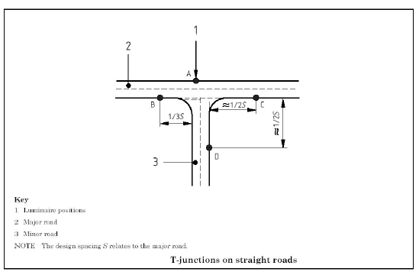

FIGURE 5.2.3.1

57
5.2.3.2 T-Junctions on Bends
The design solution for a T-junction with a curved major road can differ from that
for junctions illustrated in Figure 5.2.3.1. Typical luminaire positions for a Tjunction
on a bend are shown in Figure 5.2.3.2.

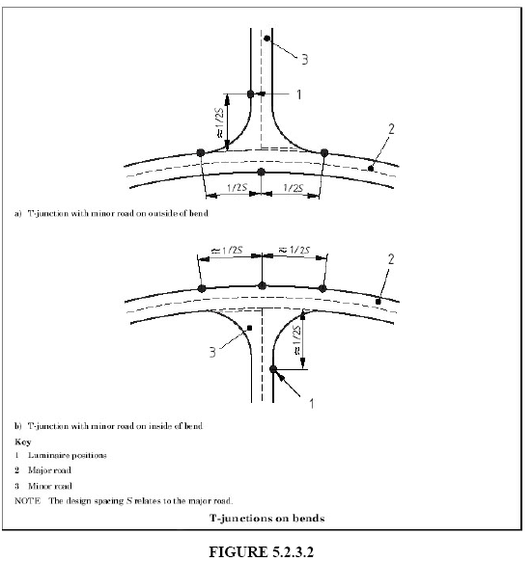

58
5.2.3.3 Staggered junctions
Two T-junctions (X) and (Y) on opposite sides of the main road, as shown in
Figure 5.2.3.3, may be considered independently in the first instance as separate
conflict areas. If they are closer together, and considered as one area, compromise
positions may be chosen for luminaires A or B.

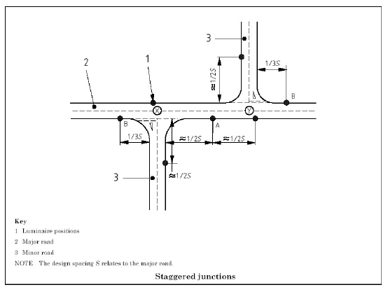

FIGURE 5.2.3.3

59
5.2.3.4 Crossroads
Typical luminaire positions for a crossroads are shown in Figure 5.2.3.4.
Luminaires A serve to reveal crossing and turning traffic.

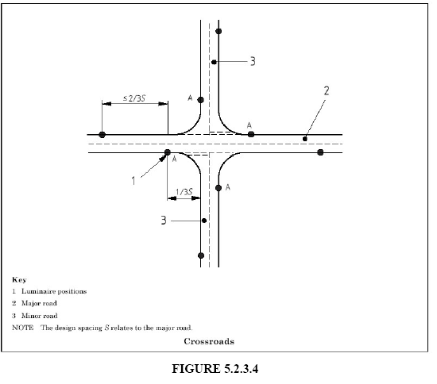

60
5.2.3.5 Y-junctions
Typical luminaire positions for a staggered arrangement at Y-junctions are shown
in Figure 5.2.3.5. These luminaires serve to reveal the junction in much the same
way as for T-junctions. Luminaire A reveals road layout and traffic movement
along the minor road.
NOTE At a Y-junction on a wide road a lighting column on a refuge or traffic
island in the mouth of a wide entry road might be necessary in order to avoid
excessive luminaire spacing.

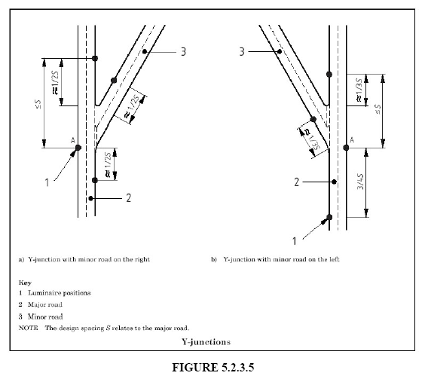

61
5.2.3.6 Fork-junctions
A fork-junction may be lit as a bend with luminaires in the major road along the
outer kerb and at appropriately reduced major road design spacings. Typical
luminaire positions for a staggered arrangement are shown in Figure 5.2.3.6.
NOTE In order to span the minor road without exceeding this design spacing,
there might be situations where one luminaire has to be mounted on a longer
bracket arm or on a lighting column situated on a refuge or traffic island in the
mouth of the minor road.

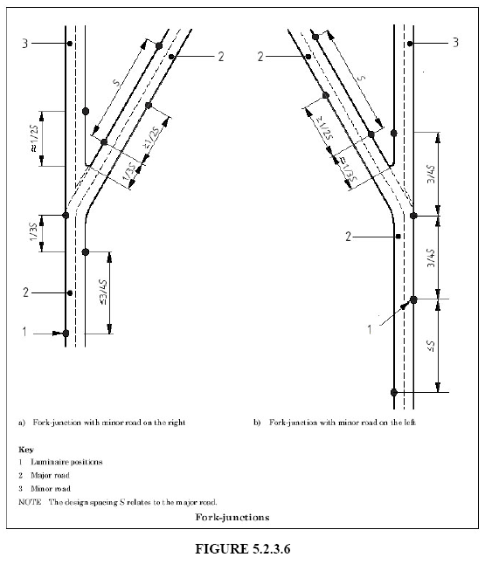

62
5.2.4 Traffic Calming Measures
In some circumstances there will be a need for a higher lighting class at the area of
traffic calming.

5.2.5 Conflict Areas

5.2.5.1 Pedestrian Crossings/ Pedestrian Crossing Points
There are two scenarios for pedestrian crossings/ Pedestrian Crossing Points. A
Pedestrian Crossing Point is provided when kerbs have been dished on both sides
of the road to encourage pedestrians to cross the road at that point.

A) Position the normal lighting so as to provide good negative contrast
This lighting is most effective when it is symmetrical from both directions along
the road. The lighting should therefore be arranged so that the crossing is at midpoint
of a span. In particular, a lighting column SHOULD NOT be placed adjacent
to a pedestrian crossing/ pedestrian crossing point. In a staggered arrangement, the
optimum solution is to provide lighting at equal distances from the centre of the
crossing. The lighting column on the approach side should be beyond the crossing
as seen by the driver. If an opposite arrangement is used (i.e. two columns opposite
one another), there should be two pairs of lighting columns at equal distances from
the centre of the crossing. At junctions this method is only applicable for a
Pedestrian Crossing Point. If a Pedestrian Crossing is sited next to junctions and
roundabouts this method is not applicable and conflict zone methods will be
required, such as B below
B) Local Lighting so as to provide additional lighting
The crossing carpet should be illuminated on the horizontal to a higher level than
provided by the normal road lighting to emphasize the presence of the crossing to
approaching drivers. Unlike A above the purpose is to provide positive contrast i.e.
illumination. One solution is to mount luminaires a short distance before the
crossing in the direction of approaching motorised traffic, and direct the light onto
the side of pedestrians facing the drivers of this traffic. This lighting will require a
strong vertical component (Stronger than the Horizontal), to ensure that pedestrians
are positively illuminated and are thus visible to approaching drivers. Zones at
either end of the road crossing, where pedestrians wait to enter the crossing, should
receive adequate illumination. Lighting confined to a narrow band around the
crossing area produces a dramatic effect in raising attention.

5.2.5.2 Ghost or Traffic Islands
To minimise delays and reduce the risk of accidents, the layout of junctions can
include traffic islands or their equivalent in roadway markings. These ghost islands
are often associated with diverging traffic lane markings with suitable directional
arrows or other instructions. To ensure efficient working, markings, as well as
other features of the junction, should be clearly visible to approaching drivers.

5.2.5.3 Roundabouts
Lighting columns should not be placed on the central traffic island opposite any
entry road, as this may increase the possibility of vehicle collisions. For small
roundabouts with kerbed central traffic islands, a centrally placed lighting column
can provide an acceptable solution. In this case, exit roads, islands and refuges
should be carefully considered in relation to the extent of the relevant conflict area.

63
5.3 LIGHTING EQUIPMENT

5.3.1 Electrical
The electrical works and the lighting installation shall include the provision of a
Public Lighting Service Pillar. The Public Lighting Service Pillar shall be
connected to the Customer Supply Pillar and be located not less than 2m from the
Customer Supply Pillar. The connection shall be via a 125mm internal diameter
red duct to ESB Specifications. The lighting installation shall be connected to the
ESB Network through this arrangement, and shall comply with the following:
- The ETCI National Wiring Rules.
- The ETCI Code of Practice for Public Lighting ET 211: 2003.

5.3.2 Lanterns
- All lanterns shall comply with the relevant Irish and BS standards.
- Lanterns shall be chosen to comply with the requirements in Section 5.1.1
including Light Pollution Requirements.
- All lanterns shall comply with the glare control restrictions of IS EN 13201.
- Within 10km of the coast (defined by the High Water Mark) the minimum
lantern IP rating shall be IP66. In all other cases the minimum lantern IP rating
shall be IP65.

5.3.3 Columns
- Columns shall be of steel construction and hot dip galvanised. Alternative
designs and construction may be required in sensitive locations including
historical/ conservation areas.
- A minimum wall thickness of 3mm shall apply.
- All columns shall be designed in accordance with IS EN 40.
- The column shall have a cable entry opening, 180 x 60mm, with the top of the
opening in accordance with section 5.3.4
- The column door opening shall have a welded in frame and weather strip all
round. The top of the door opening shall be 2700mm from the base end. The
door should be weather proof to IP 33.
- The door shall recess into the frame and be secured by two recessed 10mm trihead
screws.

5.3.4 Ducting
- All cabling connecting lights to be laid underground in a 50mm/100mm
internal diameter red duct to ESB Specifications.
- In pathways or grassed areas the duct must be buried to a minimum depth of
600mm.
- In roadways the duct must be buried to a minimum depth of 750mm.
- Warning tape must be laid at a maximum depth of 300mm below finished
ground level.
- Trenches for ducting to be constructed as per Figure 5.3.4

64

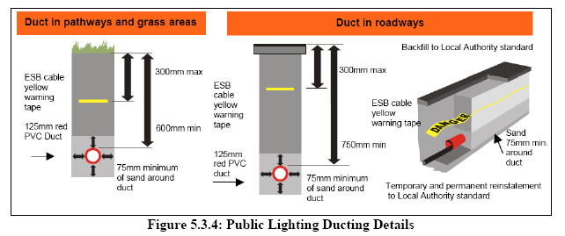

5.3.5 Column Foundations
- The excavation for lighting columns should be a minimum of 500mm in
diameter and 1.05m in depth. Larger columns will require larger excavations.
- The column should be placed in a foundation that complies with Figure 5.3.5
and Table 5.3.5.
- The sleeve should have a cable entry opening cut into it at the appropriate
location, (see Figure 5.3.5 and Table 5.3.5)
- The void between the column and the sleeve should be backfilled with sand/
quarry dust.

65

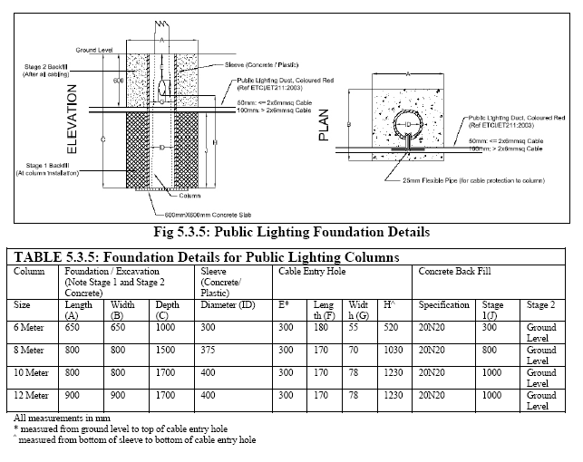

5.4 CERTIFICATION

Prior to the taking in charge by Donegal County Council of the development, the
developer shall arrange for a suitably qualified person to examine all of the above
elements of the road lighting system - including any tests that may be required - in order
to ensure that all such elements are fully in accordance with appropriate, current
standards, and, further, shall arrange for written confirmation, signed by said qualified
person, to be submitted to the Council, confirming that all elements are fully in
accordance with said current standards. All costs incurred by the developer in relation to
this certification requirement shall be borne by the developer.

Donegal County Council reserves the right to reject any such written certification where
it deems the certifying person not to be suitably qualified.

66

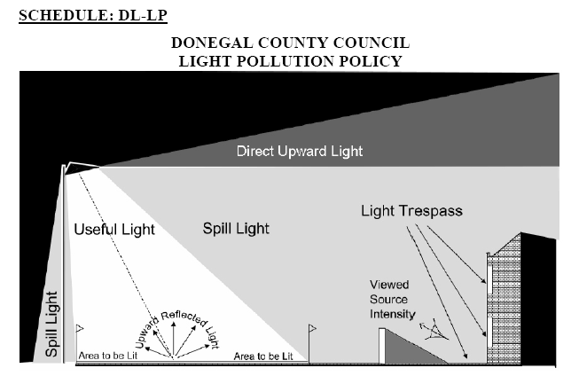
One of Donegal’s greatest assets is it’s natural beauty. Part of this asset is the night sky. In order
to protect this asset Donegal County Council endeavors to limit the amount of “waste” light that
is produced by Public Lighting.

The following must be followed in relation to Lighting Standards for Public Lighting in
Donegal.

Do not "over" light. This is a major cause of obtrusive light and is a waste of energy. The
required standards of public lighting have been set down.
Use specifically designed lighting equipment
that minimises the upward spread of light near
to and above the horizontal. Care should be
taken when selecting luminaires to ensure that
appropriate units are chosen and that their
location will reduce spill light and glare to a
minimum. Remember that lamp light output in
LUMENS is not the same as lamp wattage and
that it is the former that is important in
combating the problems of obtrusive light.
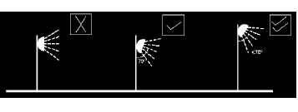
Keep glare to a minimum by ensuring that the main beam angle of all lights directed towards any potential observer is not more than 70º. Higher mounting heights allow lower main beam angles, which can assist in reducing glare. In areas with low ambient lighting levels, glare can be very obtrusive and extra care should be taken when positioning and aiming lighting equipment.
67

For sports lighting installations the use of luminaries with double-asymmetric beams designed so that the front glazing is kept at or near parallel to the surface being lit should, if correctly aimed, ensure minimum obtrusive light. In most cases it will also be beneficial to use as high a mounting height as possible, giving due regard to the daytime appearance of the installation. The requirements to control glare for the safety of road users are given in Table DL-LP-2.

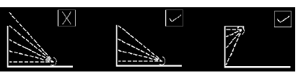
When lighting vertical structures such as advertising signs direct light downwards, wherever possible. Alternatives to downlighting may be required for particular locations. If there is no alternative to up-lighting, as with much decorative lighting of buildings, then the use of shields, baffles and louvers will help reduce spill light around and over the structure to a minimum.

For road and amenity lighting installations, light near to and above the horizontal should
normally be minimised to reduce glare and sky glow (Note ULRs in Table DL-LP-1). In
sensitive rural areas the use of full horizontal cut off luminaires installed at 0o uplift will, in
addition to reducing sky glow, also help to minimise visual intrusion within the open landscape.
However in many urban locations, luminaires fitted with a more decorative bowl and good
optical control of light should be acceptable and may be more appropriate.

LIGHTING SENSITIVE ZONES:

Donegal has been divided into two types of Lighting Areas as per Map: DL - PLZ

These are:

Zone 1: Intrinsically dark or Low light brightness landscapes: These areas consist of
National Heritage Areas, Special Areas of Conservation, Special Protection Areas and National
Parks, Areas of Outstanding Natural Beauty, etc. They also include Rural, small village, or
relatively dark urban locations

Zone 2: Medium or High district brightness areas: Small town centres or urban locations,
Town centres with high levels of night-time activity.

Where an area to be lit lies on the boundary of two zones the obtrusive light limitation
values used should be those applicable to the most rigorous zone.

68

DESIGN SPECIFICATION

The following limitations are in place for exterior lighting installations. As lighting design is not
as simple as it may seem, you are advised to consult and/or work with a professional lighting
designer before installing any exterior lighting.

The Lighting Sensitive Zones are as set out in Map: DL – PLZ

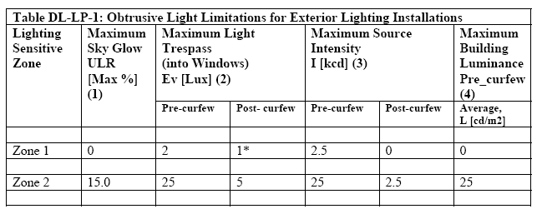

(1) ULR = Upward Light Ratio of the Installation is the maximum permitted percentage
of luminaire flux for the total installation that goes directly into the sky.
Some lighting schemes will require the deliberate and careful use of upward light – e.g.
ground recessed luminaires, ground mounted floodlights, festive lighting – to which
these limits cannot apply. However, care should always be taken to minimise any
upward waste light by the proper application of suitably directional luminaires and light
controlling attachments.

(2) Light Trespass (into Windows) measured in Ev = Vertical Illuminance in Lux and is
measured flat on the glazing at the centre of the window.
These values are suggested maxima and need to take account of existing light trespass at
the point of measurement. In the case of road lighting on public highways where
building facades are adjacent to the lit highway, these levels may not be obtainable. In
such cases where a specific complaint has been received, the developer shall endeavour
to reduce the light trespass into the window down to the after curfew value by fitting a
shield, replacing the luminaire, or by varying the lighting level.

(3) Source Intensity, I = Light Intensity in Cd
This applies to each source in the potentially obtrusive direction, outside of the area
being lit. The figures given are for general guidance only and for some sports lighting
applications with limited mounting heights, may be difficult to achieve.

(4) Building Luminance, L = Luminance in Cd/m2
This should be limited to avoid over lighting, and related to the general district
brightness. In this reference building luminance is applicable to buildings directly
illuminated as a night-time feature as against the illumination of a building caused by
spill light from adjacent luminaires or luminaries fixed to the building but used to light
an adjacent area.

Curfew = 23:00 hrs
* = From Public road lighting installations only
69

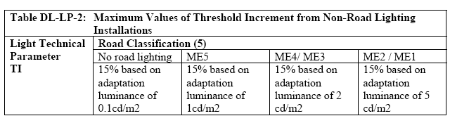

TI = Threshold Increment is a measure of the loss of visibility caused by the disability glare
from the obtrusive light installation

(5) Road Classifications as given in EN 13201-2: 2003 Road lighting Performance
requirements
Limits apply where users of transport systems are subject to a reduction in the ability to
see essential information. Values given are for relevant positions and for viewing
directions in path of travel.

70
SCHEDULE: DL:-LC

Donegal County Council: Specification for Lighting Classes (NON-TRL)

 | Low Traffic Flow |  | Moderate Traffic Flow |  | High Traffic Flow
 | (Local Traffic Only) |  | (Local Traffic + Amenities. Generally <  1,000 AADT) |  | Regional, National Roads or Roads>  1,000 AADT
 | Lighting Sensitive  Zone 1 | Normal  Zone 2 | Lighting Sensitive  Zone 1 | Normal  Zone 2 | Lighting Sensitive  Zone 1 | Normal  Zone 2
Crime Rate
Low | S6 | S5 | S5 | S4 | S4 | S3
Moderate | S5 | S4 | S4 | S3 | S2 | S2
High | S3 | S3 | S3 | S2 | S2 | S2

N.B. The above table is not applicable where Ra<60. i.e. the above table only applies to “White Light” Installations.
Lighting Sensitive are the areas identifies in the Public Lighting Zones Map (Map: DL – PLZ) and consist of NHA, SAC, SPA and EHSA areas.
Lighting Classes may be increased by one lighting class in the vicinity of traffic calming measures.

71
72

- APPENDIX A
SPECIFICATION FOR WATER PUMPING STATIONS

73
Minimum Specification for Water Pumping Stations

1 General Design Criteria
It is the responsibility of the designer to ascertain whether or not the Council’s water mains, and if applicable pump stations, have sufficient capacity to meet the requirements of the proposed installation. It is the responsibility of the designer to ensure that any boosting proposal is sufficient to meet the requirements of the development, subject to any conditions the Local Sanitary Authority may impose to protect the public water supply. It is also the responsibility of the designer to liase with the local sanitary authority and establish the type of installation required for the proposed development. The primary options are:
- Pumping in-line directly to distribution.
- Pumping in-line to storage.
- Pumping from sump directly to distribution.
- Pumping from sump to storage.

The design capacity for the pump station will be based the following assumptions:
- • The design demand for each domestic dwelling is assumed to be 450 litres/day

When calculating demands generated by schools, crèches, industrial or commercial undertakings etc., the designer should liase with the local sanitary authority to establish baseline demands for the purposes of design.

2 Required Drawings
All proposals for pumping stations are to be accompanied by the following:
2.1 General arrangement drawings
  - 1. Pump station
  - 2. Sump chamber (if required)
- Note: Drawings should clearly show valves and pipework in the vicinity of the pump station.

2.2 Site layout drawing
- Location of the pump station and all pipework within the development.
- The valves and scour main must be clearly indicated.

2.3 Equipment Documentation
The developer shall make available;
  - A site specific safety statement with associated risk assessments covering all operation and maintenance activities, which should form a part of the schemes safety file, will be required at take-over stage. The safety file is a record of information for the end user, which focuses on health and safety and must be made available to Donegal County Council before handover of the asset
  - Pump details including performance curve and power rating.
  - Manufacturer’s data sheet for a proposed flow meter.
  - Two hard copies of all operation & maintenance manuals relating to all installed equipment are to be submitted to the Local Sanitary Authority when the pump station is to be taken in charge. This is to include electrical data sheets for pumps, level control, telemetry etc.
  - The manufacturers standard annual maintenance contract
  - A list of the manufacturers recommended spare parts for 20 years operation, including the current cost for each item
  - Warranty documents for all installed equipment.

74

3 Pumping Station

3.1 General Configuration
  - The pumping station should be located so that ease of access for maintenance is ensured.
  - Aluminium or galvanised mild steel access covers are to be provided on all chambers and these shall be hinged and spring assisted. Minimum allowable size of personnel access covers is 675 mm square or 700mm diameter. All covers must be lockable. Note covers shall be suitable for vehicular and/or pedestrian load as required. All covers must be third party certified.
  - Particular design of proposed sump should be agreed with the Local Sanitary Authority and as a minimum should have a 30 year design life. Concrete block constructions will not be permitted.
  - In installations where a kiosk is proposed it must consist of two separate compartments. The first to house the pumping equipment and the second to house the control equipment.
  - In installations where pumping is direct to distribution the preferred method for pump control is by a variable speed drive and responding to pressure transducer.

3.2 Controls
  - A sluice valve shall be provided on the inlet water main to the pump to facilitate maintenance.

4 Drinking water sump Storage
In installations where a sump is deemed to be necessary by the Local Sanitary Authority the designer shall take account of the following:
- When pumping directly to distribution the sump should be sized for 1.75 days demand storage.
- When pumping from sump to storage the combined volume between sump and storage tank should be not less than two days design demand.
- All sumps should be designed to incorporate an overflow drainage pipe to local surface water drainage system. This overflow pipe must be protected from foreign matter contamination by external elements e.g. Rodents, surface water flooding etc.
- All sumps should be designed to incorporate a low level scour pipe to ensure that the sump can be fully drained. The scour valve fitted on the scour pipe must be external to the sump. Operation of this scour valve must be facilitated by using a standard water key from ground level.

5 Control House

5.1 General Configuration
  - The approved standard pumphouse / kiosk details can be supplied to Contractors and pump suppliers on request, so that any confusion in relation to internal dimensions, ceiling heights, etc can be avoided. The station is to be constructed to current Health, Safety and Welfare at Work standards.
  - The pumping station, sump chamber, valves and control building / kiosk shall be completely enclosed by a suitable boundary treatment, with a design appropriate to the positioning of the station, which will be secured with lockable gates. A prominent warning sign shall be mounted on the gate. This shall be black text on yellow background.
  - Site lighting to be provided in accordance with section 5 – Public Lighting
  - An insulated water tap with a double check valve is to be supplied and installed beside the pumping station within the compound with lever valve located in building /kiosk.
  - Access to the pumping station should be via a 4m paved roadway linking to public roadway to allow for future maintenance of the station. Developer must prove and have full legal title to the access road and the site of the proposed water pumping station

75

5.2 Electrical Requirements
- The control house will have an independent metered supply with meter cabinet located on external wall as per ESB requirements in the case of a pumphouse and located within control housing in the case of a kiosk. Control panel to be metal with enamel coating.
- Phase failure unit with upper and lower limits to be provided where 3 phase supply is used.
- All electrical panels should have 25% spare capacity for ease of working and for any future additional equipment.
- The control panel shall have hand / off / auto selector for each pump, run light for each pump, main isolator, duty select switch and reset buttons. It shall incorporate ammeters, hour run meters for both pumps and volt meter on incoming mains.
- The control panel shall have provision for connection to an external generator connection.
- Motor rated Circuit Breakers (MCBs) to be installed in main panel after main fuses to protect motors.
- Provision to be made in control panel for a future telephone dial and alarm system in the event of a malfunction. Responsibility for the future alarm system will be assumed by the Local Sanitary Authority, however normally closed contacts to be made available for alarm system to connect into.
- Provide additional power point 1 No. 110volt and 1 No. switched 220v socket outlet protected by residual circuit breaker (RCB) fitted at main panel.
- Lockout timer should be activated by dry running protection signal and / or high / low pressure switch depending on whether the installation is pump to reservoir or booster station, or in event of valve being shut.
- A lockout indicator lamp to be mounted on front panel.
- Hour run meters to be fitted for each pump unit and clearly marked
- Trip lights to be fitted for each motor.
- Hold-off timer (to avoid hunting) when voltage re-applied to pumps. This should be 0-3 minutes rating. This may be incorporated with the phase failure unit.
- Sump probes should be ultrasonic type unless otherwise approved by the local sanitary authority.
- Pumphouse / kiosk splashproof lighting must be provided.
- A low wattage heater for frost protection to be mounted adjacent to pumps at a low level, but located such as to avoid scorch damage to other equipment, conduits etc. This heater should be provided with switch and thermostatic control.
- On larger pumping sets, phase conversion units will have to be used. Static phase converters or rotary converters are to be avoided. Units that include a softstart or variable speed drive are to be used instead. Three phase E.S.B. mains should be provided except where cost is prohibitive (taking into consideration long-term maintenance costs etc). (Any proposal to install a phase converter should be discussed with the Local Sanitary Authority section before proceeding).
- When pumping to reservoirs only, it would be preferred that a reservoir control be installed, and a control system to allow for maximum use of night rate electricity, and minimise the daytime pumping, but always to keep the reservoir at a safe minimum level. This control would be made up of two radio tranceivers and a small PLC, and /or other equipment to make the system effective. This signal would provide an analogue signal for the level of the reservoir at the pumping station.
- AC. Drives. All drives to include as standard, an RFI Filter, to comply with regulations.
  - All metal equipment on the pump station site e.g. pump guide rails, covers, ladders, rising main etc shall be bonded to earth. Earth rods shall be installed in inspection pits with removable covers.
- All electrical ducts are to be installed with long radius bends.
- A completion certificate for electrical installations will be required for each location.
- The complete electrical installation is to comply with RECI and ESB standards.

76

6 Pumps

6.1 General Configuration
- Pumps shall be provided in duty/standby arrangement and shall multi-stage vertical or centrifugal designed for the pumping of drinking water. They shall be capable of being installed and removed from a support frame.
- Proposed pumps should be examined and approved by Local Sanitary Authority. The proposed pump shall not necessarily be accepted (a) if the above requirements are not all met, (b) if the supplier has in the past not provided equipment of reasonable quality and installed to a reasonable standard, (c) if the supplier can not provide evidence (if required) of the proven quality and durability of pump units motors, electrical switch panel and control gear.
- Pumps shall include 2 copies of Panel Wiring Diagrams, 2 copies of Maintenance Manuals which shall include pump rating curves for installed units together with parts listings clearly illustrated and a copy of Operating Instruction sheet suitable for mounting at new control panel and including small mimic diagram of general pipe work layout including valves, controls etc. The language for all associated literature shall be English.
- Each pump shall be clearly labelled indicating pump No.1 and pump No.2.
- Pumps and motor units shall be provided with manufacturers name / detail plate containing Model Type, Serial No. and rating etc.
- Pumps shall be fitted with lifting eyes positioned to allow their removal by overhead crane if required by weight of pump under manual handling guidelines.
- The pump shall be mounted on a galvanised support frame with 100mm clearance from the floor. The support frame should be designed to be of suitable strength to support the weight of the pump and pipework. Any fixings between pump and support frame should be easily accessible to facilitate pump removal.
- All pipe work and valves shall be ductile iron, flanged or galvanised pipe as approved by Local Sanitary Authority.

6.2 Metering
- The rising main shall be fitted with a magnetic (MAG) type flow meter. This is to be located on the discharge side of the pump. The flowmeter shall have a remote interface located in the control house. The flow meter shall be IP67; it shall have a polyurethane liner and be capable of 0.5% accuracy. Power and communications cables shall be separated into separate ducts.
- A sluice valve should be installed on the rising main up stream of the flow meter to prevent draining back of the rising main where the flow meter needs to be removed for replacement or repair.

6.3 Pump Technical Requirements
- The pumps shall be multi-stage vertical or end suction centrifugal as required. All shafts and couplings to have safety guards.
- Pump cables shall be suitably supported inside the pumping installation on cable trays / trunking to prevent stretching or stressing of the cables.
- Pumps shall be capable of a minimum of 12 starts per hour without motor overheating.
- Pumps shall be provided with individual air release pipes, 19mm bore, with stop valves and automatic air valves.
- Motors and pumps shall have high efficiency ratings.
- Motor and motor housing shall be bolted to the pump housing unless otherwise agreed by the Local Sanitary Authority.
- Motors and pumps should include a stainless steel stamped nameplate secured to the housing. The nameplate should include as a minimum the phase, voltage, kW, pump weight, confirmation of high efficiency motor, manufacturer name, serial number and date of manufacture.

77
- Where a frequency inverter is proposed the motor should be suitable for use with an inverter and derating of a standard motor will not be accepted. The motor should be specifically labelled for inverter duty.
- Pressure gauges and switches on the inlet and outlet pipes. 3 No. pressure gauges, isolated by valves, of the glycerine filled type are required. 2 No. pressure gauges are required, one on either side of the inlet strainer and one on the discharge pipe in inline installations only.
- Inlet water strainer on suction end and fitted with isolating valves within the pumphouse where inline installations are used.
- Controls must provide protection to prevent the pump from dry running in all instances.
- Foot valves and inlet ball valves in sump should be located where access is convenient, for maintenance purposes in installations where a sump is required.
- Where a pressure vessel is used for surge protection purposes required it should be fitted with automatic air charging facility, if it has not got a diaphragm. All pressure vessels shall be accompanied by pressure test certificate.

7 Commissioning
On completion of construction the Local Sanitary Authority should be notified so that the complete finished installation can be inspected. Written approval to commence operation of the installation will only be granted by the Local Sanitary Authority where the installation has been completed to the above requirements and all necessary documentation has been provided.
It will be a requirement that the operation of all pumps, pump protection devices etc are demonstrated prior to approval.

78

- APPENDIX B
SPECIFICATION FOR WASTEWATER PUMPING STATIONS

79
Minimum Specification for Wastewater Pumping Stations

1 General Design Criteria
It is the responsibility of the designer to ascertain whether or not the Local Sanitary Authority sewer mains, and if applicable pump stations, have sufficient capacity to meet the requirements of the proposed installation. It is the responsibility of the designer to ensure that Area Classification is applied to the design of the pump station to identify the potential for flammable or explosive atmospheres to develop in and around the pump station. It is also the responsibility of the designer to ensure that any boosting proposal is sufficient to meet the requirements of the development, subject to any conditions the Local Sanitary Authority may impose to protect the public sewerage scheme. This specification refers to wet well designs only. Any proposed dry well design will be dealt with individually by the Local Sanitary Authority.

The design capacity for the pump station will be based the following assumptions:
- The load from each domestic dwelling is assumed to be equivalent to 3 PE
- The hydraulic load per PE is 220 litres/day.

Particular design parameters should include:
- Minimum Level in Sump (i.e. Cut out level).
- Maximum Level in Sump (i.e. Cut in level).
- Invert level of pipe at discharge point.
- Length of rising main.
- Pipe type and diameter of rising main.
- Volume of effluent in sump between cut in and cut out levels.
- Approximate pumping rate (i.e. m³/h or litres/sec).
- Dry weather flow (DWF) of proposed development
- Ratio of design flow to DWF.
- Power supply available.

When calculating loads generated by schools, crèches, industrial or commercial undertakings etc., the EPA guidelines, taken from “Treatment Systems for Small Communities, Business, Leisure Centres and Hotels” are to be used.

2 Required Drawings
All proposals for pumping stations are to be accompanied by the following:

2.1 General arrangement drawings
    - 1. Pump station
    - 2. Emergency overflow chamber
    - 3. Valve chamber
- Note: Drawings should clearly show the invert levels of all pipes connecting to chambers, over flows, cut in/cut out levels etc.

2.2 Site layout drawing
- The levels of all site manholes in relation to the levels of all pipes feeding the pump station.
- The levels of overflows from the pump station. Alternatively this may be provided in the form of a hydraulic flow diagram.

80

2.3 Equipment Documentation
The developer shall make available;
- A site specific safety statement with associated risk assessments covering all operation and maintenance activities, which should form a part of the schemes safety file, will be required at the take-over stage. The safety file is a record of information for the end user, which focuses on health and safety and must be made available to Donegal County Council before handover of the asset
- Pump details including performance curve and power rating.
- Manufacturer’s data sheet for a proposed flow meter.
- Two hard copies of all operation & maintenance manuals relating to all installed equipment are to be submitted to the Local Sanitary Authority when the pump station is to be taken in charge. This is to include electrical data sheets for pumps, level control, telemetry etc.
- The manufacturers standard annual maintenance contract
- A list of the manufacturers recommended spare parts for 20 years operation, including the current cost for each item
- Warranty documents for all installed equipment.

3 Pumping Station

3.1 General Configuration
- Developer must prove and have full legal title to the access road and the site of the proposed water pumping station
- The pumping station should be located away from houses and buildings in accordance with EPA guidelines in order to minimise the risk of odour nuisance.
- The pumping station sump should preferably be of circular pre-cast concrete sections surrounded with a minimum thickness of 200mm C20 concrete. The use of GRP/FRP pump stations is also acceptable and will be subject to a 30-year design life. The manufacturer’s data sheet and installation instructions shall be submitted.
- A minimum distance of 200mm shall be provided between the invert of the lowest inlet sewer pipe to the chamber and the top water level of the pump chamber.
- The pump station is to be provided with a separate ductile iron pipe (min 100mm dia) commencing at between 125 – 150mm from the pump station floor and terminating with a female Bauer coupling in a chamber separate to the valve chamber. There should be sufficient space around the Bauer coupling for the connection of a vacuum tanker hose. This facility combined with the ductile iron pipe provided from the Pumping Station, will enable pumping down of the pump station by vacuum tanker in the event of the pumps being out of service.
- The pump delivery pipe work within the pump chamber shall be opposite the inlet sewer to avoid the formation of vortices.
- Aluminium or galvanised mild steel access covers are to be provided on all chambers and these shall be hinged and spring assisted. Minimum allowable size of personnel access covers is 600 mm square or diameter. All covers must be lockable. Note covers shall be suitable for vehicular and/or pedestrian load as required. All covers must be third party certified.
- Access design should be in accordance with the entry requirements as per the Codes of Practices for Working in Confined Spaces.
- All pumping stations are to include a cast-in socket, lifting davit and lifting tackle suitable for the lifting of pumps from the pump station. Davits and sockets shall be galvanised and davits shall not weigh more than 35 kg. Where the size of the proposed pumps are unsuitable for this type of lifting then the designer shall submit a specific design proposal to be agreed by the Local Sanitary Authority.
- Where the lifting height requires it the lifting chains shall be provided to BS 4942 incorporating a large link at not more than one metre intervals. It is a requirement
81
that the equipment be stored in the pump control house and should be suitable for this purpose. In cases where the pump control house is a kiosk then this equipment should be stored in a separate compartment in the control kiosk. The manufacturers name and SWL of any lifting equipment should be stamped on a stainless steel plate attached to the equipment.

3.2 Controls
- A penstock / sluice valve shall be provided on the inlet sewer pipe to the pump chamber to facilitate maintenance.
- Regardless of pump manufacturers’ recommended cut-out levels it is a requirement that min cut out level should not be set below the top of the pump motors.
- Level detection should be ultrasonic so that the probe can be located out of the liquid and therefore will not require cleaning. A standby probe shall be provided (e.g. float switch for high level) in the event of ultrasonic failure.

4 Emergency Overflow Chamber

All pumping station installations are required to have an emergency overflow chamber for overflows which may occur due to pumps being out of operation for long periods due to power failure or mechanical/electrical failure of the installation. The emergency overflow chamber will meet the following requirements:
- 8 hours retention capacity at dry weather flow in general, however, in certain sensitive locations the Regional Fisheries Board Recommendations will apply.
- Overflow pipe shall be 200mm diameter minimum.
- Return pipe feeding back into the pump chamber. This shall be fitted with a flap valve on the pump chamber side and shall be 200mm diameter minimum
- Designed and constructed with benching so as to be self-draining to the pump chamber.
- Fitted with covers suitably large to allow hosing down of the chamber. Covers shall be galvanised mild steel (GMS) and hinged, spring assisted. The covers shall be suitable for pedestrian and/or vehicular load as required and lockable.
- Shall be fitted with two vent stacks capped with anti bird cowls.

5 Control House

5.1 General Configuration
- The approved standard pumphouse / kiosk details can be supplied to Contractors and pump suppliers on request, so that any confusion in relation to internal dimensions, ceiling heights, etc can be avoided. The station is to be constructed to current Health, Safety and Welfare at Work standards. The welfare section should have a hand wash facility with hot water, storage space for PPE, and a storage space for all equipment used with the general maintenance of the station.
- The pumphouse / kiosk should be positioned as far away as possible (minimum 2m) from the pump chamber, and the valve chamber (where it has been fitted with a drain to the pump chamber). This is for safety purposes and to allow adequate working space for pump removal and maintenance activities.
- The pumping station, emergency over flow chamber, valve chamber and control building shall be completely enclosed by a suitable boundary treatment, with a design appropriate to the positioning of the station, which will be secured with lockable gates and warning sign. A prominent warning sign shall be mounted on the gate. This shall be black text on yellow background.
- Site lighting to be provided in accordance with section S5.3 Public lighting – Minimum Illuminance Levels
- An insulated water tap with a double check valve is to be supplied and installed beside the pumping station with lever valve located in building.
- Access to the pumping station should be via a 4m paved roadway linking to the
82
public roadway to allow for future maintenance of the station.
- A fire hydrant is to be provided within the pumping site.

5.2 Electrical Requirements
- The control house will have an independent metered supply with meter cabinet located on external wall as per ESB requirements in the case of a pumphouse and located within control housing in the case of a kiosk. Control panel to be metal with enamel coating.
- Phase failure unit with upper and lower limits to be provided where 3 phase supply is used.
- All electrical panels should have 25% spare capacity for ease of working and for any future additional equipment.
- The control panel shall have hand / off / auto selector for each pump, run light for each pump, trip light for over temperature on each pump, trip light for seal failure on each pump, main isolator, duty select switch and reset buttons. It shall incorporate ammeters, hour run meters for both pumps and volt meter on incoming mains.
- The control panel shall have provision for connection to an external generator connection.
- An intrinsically safe low wattage heater to be mounted within the control panel to keep electrics and switchgear dry.
- Motor rated Circuit Breakers (MCBs) to be installed in main panel after main fuses to protect motors.
- Power & control ducts between the pump chamber & control panel/s are to be fully sealed to prevent ingress of gas from pump chamber to panels.
- Provision to be made in control panel for a future telephone dial and alarm system in the event of a malfunction. Responsibility for the future alarm system will be assumed by Donegal County Council, however normally closed contacts to be made available for alarm system to connect into.
- Provide additional power point 1 No. 110volt and 1 No. switched 220v socket outlet protected by residual circuit breaker (RCB) fitted at main panel.
- Internal lighting shall be provided.
  - All metal equipment on the pump station site e.g. pump guide rails, covers, ladders, rising main etc shall be bonded to earth. Earth rods shall be installed in inspection pits with removable covers.
- All electrical ducts are to be installed with long radius bends.
- A completion certificate for electrical installations will be required for each location.
- The complete electrical installation is to comply with RECI and ESB standards.

6 Pumps

6.1 General Configuration
- In certain circumstances pumps shall be provided in duty/assist/standby as required by the Local Sanitary Authority and shall be submersible and specifically designed for the pumping of raw, unscreened domestic sewage. They shall be capable of being installed and removed from below ground level using guide rails and pulley block.
- Proposed pumps should be examined and approved by the Local Sanitary Authority. The proposed pump should not necessarily be accepted (a) if the above requirements are not all met, (b) if the supplier has in the past not provided equipment of reasonable quality and installed to a reasonable standard, (c) if the supplier can not provide evidence (if required) of the proven quality and durability of pump units motors, electrical switch panel and control gear.
- Pumps shall include 2 copies of Panel Wiring Diagrams, 2 copies of Maintenance Manuals which shall include pump rating curves for installed units together with parts
83
listings clearly illustrated and a copy of Operating Instruction sheet suitable for mounting at new control panel and including small mimic diagram of general pipe work layout including valves, controls etc. The language for all associated literature shall be English.
- There shall be a plate near to the top of the pump chamber indicating pump No.1 and pump No.2.
- Pumps and motor units shall be provided with manufacturers name / detail plate containing Model Type, Serial No. and rating etc.
- Pumps shall be fitted with lifting eyes positioned to allow their removal by overhead crane and shall be self locating when lowered into position.
- Pumps shall have low flow protection so that dry running will be prevented.
- The pump shall be mounted on a bedplate or sole plate.
- All guide rails and anchor bolts shall be red band galvanised steel. Note that under no circumstances should galvanised steel surfaces come in contact with each other anywhere in the installation.
- All pipe work and valves shall be ductile iron NP16 for sewage as per BS/EN 598.

6.2 Pump Chamber
- The chamber floor is to be benched to a minimum of 15º towards the pumps to reduce the build up of solids in the chamber.
- The sump level is to be controlled by ultrasonic control or equivalent approved by the Local Sanitary Authority.
- The pump chamber shall be fitted with a vent stack capped with an anti bird cowl.
- The valve chamber shall contain the pump rising main entering through one side of the chamber followed by a non-return valve followed by a sluice valve.
- The rising main non-return valves shall be mounted horizontally and have removable top covers positioned in a chamber at ground level. They shall have a ductile iron body and disc, resilient seated disc and stainless steel hinge pin. Each valve shall be complete with lever and weight and shall be double flanged type. The valve chamber shall be suitably sized to allow 250mm minimum clearance around all flanged joints within the chamber. All chambers shall be free draining returning to the sump.
- The rising main shall be fitted with a magnetic (MAG) type flow meter This is to be located in the valve chamber or a separate chamber if preferred on the discharge side of the non-return valve. The flowmeter shall have a remote interface located in the control house. The flow meter shall be IP67; it shall have a polyurethane liner and be capable of 0.5% accuracy. Power and communications cables shall be separated into separate ducts.
- A sluice valve should be installed on the rising main up stream of the flow meter to prevent draining back of the rising main where the flow meter needs to be removed for replacement or repair.

6.3 Pump Technical Requirements
- The pumps shall be vertically mounted, single speed, with large freeways, complete with motors, vertical drives, shafting, coupling and guards.
- Impellors shall be of best quality cast iron, designed so that rags and stringy matter will not adhere to them. They shall be capable of passing raw sewage and of passing solids of up to 75mm diameter through the impeller without choking. Wearable parts should be easily replaceable. The impellers shall be keyed and positively secured to the high tensile steel shafts, and shall be tested for static and dynamic balance. The pumps shall be designed so that the impellers can be removed without disturbing the pump bodies.
- Pump cables shall be suitably supported inside the pump chamber to prevent stretching/stressing of the cables and this should allow removal of the pumps from the pump chamber without fouling of the cables.
- Minimum pump discharge size shall be 80mm.
84
- Pumps shall be capable of a minimum of 12 starts per hour without motor overheating.
- Pumps shall be sized for 3 times dry weather flow.
- Pumps shall be provided with individual air release pipes, 19mm bore, with stop valves and automatic air valves.
- Pump casing shall be manufactured from cast iron with impeller and shaft manufactured from duplex stainless steel (typically grade 2304 or 2205).
- Pump shaft shall have a mechanical seal provided by tungsten or silicon carbide mechanical seals.
- The pump shaft seal or primary seal shall be housed in an oil filled chamber containing electronic seal monitoring.
- The secondary seal between the seal chamber and the motor shall be a mechanical seal. This shall be similar to the primary seal or shall have tool steel seal faces.
- Bearings shall have a B-10 life rating.
- Motors shall be High Efficiency with class F insulation.
- Motor and motor housing shall be bolted to the pump housing. Shrink or press fit assemblies will not be accepted.
- Motors must include stator over-temperature protection in the form of thermistors embedded in each phase of the windings. Over-temperature protection should automatically re-set when temperature returns to normal.
- The motors should be capable of running for short periods out of the pumped liquid.
- Motors and pumps should include a stainless steel stamped nameplate secured to the housing. A duplicate stainless steel nameplate is to be mounted in the control cabinet. The nameplate should include as a minimum the phase, voltage, kW, pump weight, confirmation of high efficiency motor, manufacturer name, serial number and date of manufacture.
- Where a frequency inverter is proposed the motor should be suitable for use with an inverter and derating of a standard motor will not be accepted. The motor should be specifically labelled for inverter duty.

7 Commissioning

On completion of construction the Local Sanitary Authority should be notified so that the complete finished installation can be inspected. Written approval to commence operation of the installation will only be granted by the Local Sanitary Authority where the installation has been completed to the above requirements and all necessary documentation has been provided.
It will be a requirement that the operation of all pumps, pump protection devices, etc are demonstrated prior to approval.

85

- APPENDIX C

SPECIFICATION FOR WASTEWATER TREATMENT PLANTS

86

MINIMUM SPECIFICATION FOR WASTEWATER TREATMENT PLANTS

1 GENERAL DESIGN CRITERIA

Multiple housing developments proposing to utilise a communal treatment system will not be permitted outside of the control points of any urban area in accordance with Local Authority Policies.

In development proposals where a Wastewater Treatment Plant is proposed, the calculations for loads generated by the development should be based on the guidelines issued by the E.P.A. The Treatment Plant should be enclosed by a suitable boundary treatment, with a design appropriate to the positioning of the treatment plant, which will be secured with lockable gates and warning sign. Access to the Treatment Plant should be by 4m wide paved road linking to a public roadway.

2 REQUIRED DRAWINGS

All proposals for Wastewater Treatment Systems are to be accompanied by the following:

2.1 GENERAL ARRANGEMENT DRAWINGS
- Treatment Plant including each stage process
- Emergency overflow chamber (when required)
- Mechanical And Electrical arrangements

Note: Drawings should clearly show the invert levels of all pipes connecting to chambers, overflows, cut-in and cut-out levels etc.

2.2 SITE LAYOUT DRAWING
- The location of each of the elements of the plant must be clearly laid out.
- All inverts levels should be clearly identified.

2.3 EQUIPMENT DOCUMENTATION
The Developer shall make available;
  - A site specific safety statement with associated risk assessments covering all operation and maintenance activities, which should form a part of the schemes safety file, will be required at take-over stage. The safety file is a record of information for the end user, which focuses on health and safety and must be made available to Donegal County Council before handover of the asset.
  - Pump details including performance curve and power rating.
  - Manufacturer’s data sheet for a proposed flow meter.
  - Two hard copies of all operation & maintenance manuals relating to all installed equipment are to be submitted to the Local Sanitary Authority when the pump station is to be taken in charge. This is to include electrical data sheets for pumps, level control, telemetry etc.
  - The manufacturers standard annual maintenance contract
  - A list of the manufacturers recommended spare parts for 20 years operation, including the current cost for each item.
  - Warranty documents for all installed equipment.

3 TREATMENT PLANT

3.1 GENERAL CONFIGURATION
- The Treatment Plant should be located away from houses and buildings in accordance with EPA requirements in order to minimise the risk of odour nuisance.
- The Treatment Plant shall be installed in accordance with Manufacturer’s instructions.
87
- The Treatment Plant shall not be placed in the common “green” area provided in front of houses and other buildings.
- In cases where a percolation area or polishing filter is proposed for final discharge to ground water system then an area other than the common “green” area in front of houses must be used.
- All open tanks and/or chambers associated with the Treatment Plant must be covered. All covers shall be designed in accordance with Specification for Wastewater Pumping Stations.

3.2 CONTROLS
- A penstock or SV shall be provided on the inlet sewer pipe to the treatment plant.
- Standby systems must be provided with automatic changeover for all critical electrical and mechanical elements of the Treatment Plant.

4 EMERGENCY OVERFLOW CHAMBER

In certain sensitive locations it may be necessary to provide an emergency overflow chamber with return wastewater pumping station to receive effluent overflow from the Treatment Plant in circumstances when a failure of equipment occurs. It is the responsibility of the designer to ascertain whether or not this requirement is necessary by contacting the Local Sanitary Authority. Design considerations are as per specification for wastewater pumping stations: Emergency Overflow Chamber.

5 CONTROL HOUSE

5.1 GENERAL CONFIGURATION
- The control house / kiosk detail requirements shall be as per specification for wastewater pumping stations.

5.2 ELECTRICAL REQUIREMENTS
- Electrical requirements shall be designed in accordance with Specification for Wastewater Pumping Stations.

6 QUALITY OF FINAL EFFLUENT

It shall be necessary in all cases for the designer to provide a chamber in the effluent stream for the purposes of wastewater sampling. All samples taken at this proposed location should be representative of the general effectiveness of the treatment plant in terms of wastewater quality of the final effluent.

It should be noted that in systems where the final phase of treatment relies on a percolation area or polishing filter discharging to ground water directly then the sampling chamber must be located before these items in the effluent stream due to the difficulty in acquiring a representative sample at the end of the process. In this circumstance the Local Sanitary Authority will set the minimum quality allowable at that stage of the process. It is generally accepted that the performance of Treatment Plants ultimately discharging to ground water will need to achieve a higher standard of treatment as a high quality wastewater will need to be achieved prior to final polishing. (Say e.g. 25mg/l BOD and 35mg/l SS standard or better before final polishing) In certain areas more stringent requirements will be required for other parameters such as ammonia, nitrates and phosphates etc.

7 COMMISSIONING

On completion of construction the Local Sanitary Authority should be notified so that the complete finished installation can be inspected. Written approval to commence operation of the installation will only be granted by the Local Sanitary Authority where the installation has been completed to the above requirements and all necessary documentation has been provided.
All waste water treatment shall be tested and certified independently prior to final certification.
88

